# Installing webservers and connection to the server

* 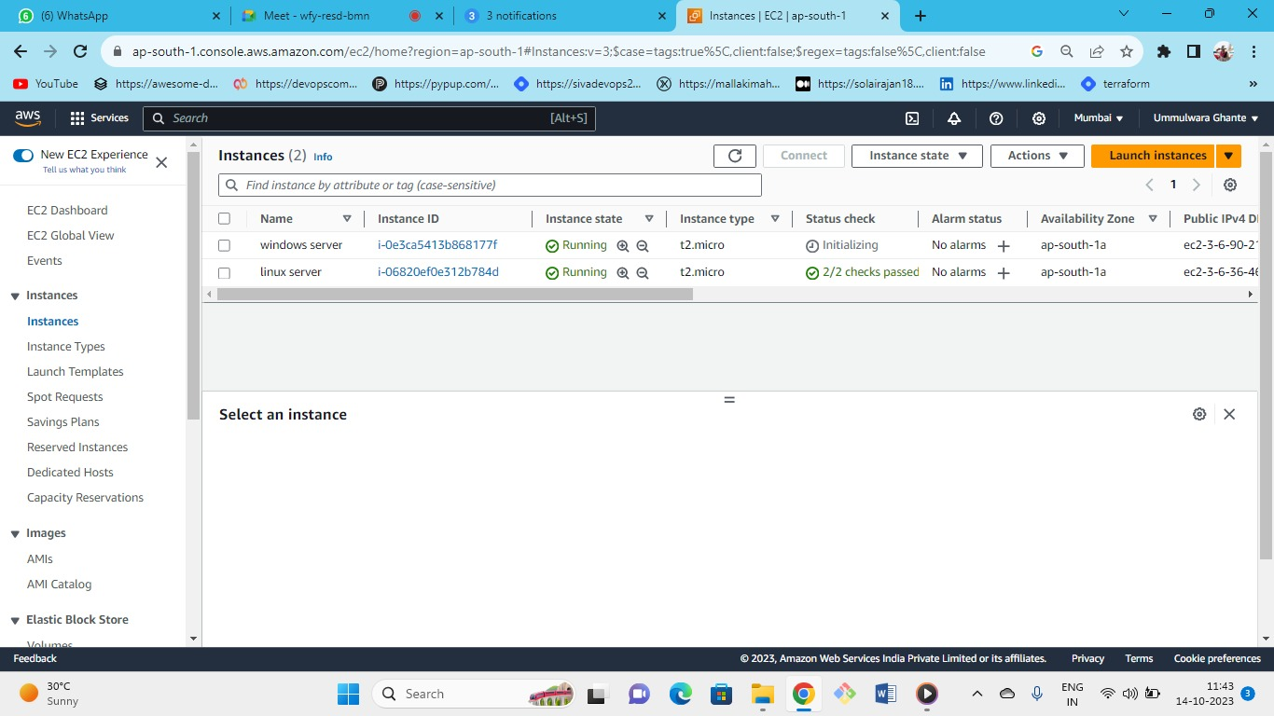



* server(linux)--->instance type(t2.micr0)--->keypair(create new or keep old one)--->security group (new or existing)-->storage(gp2)--->launch.
* server(windows)--->instance type(t2.micr0)--->keypair(create new or keep old one)--->security group (new or existing)-->storage(gp3)--->launch.

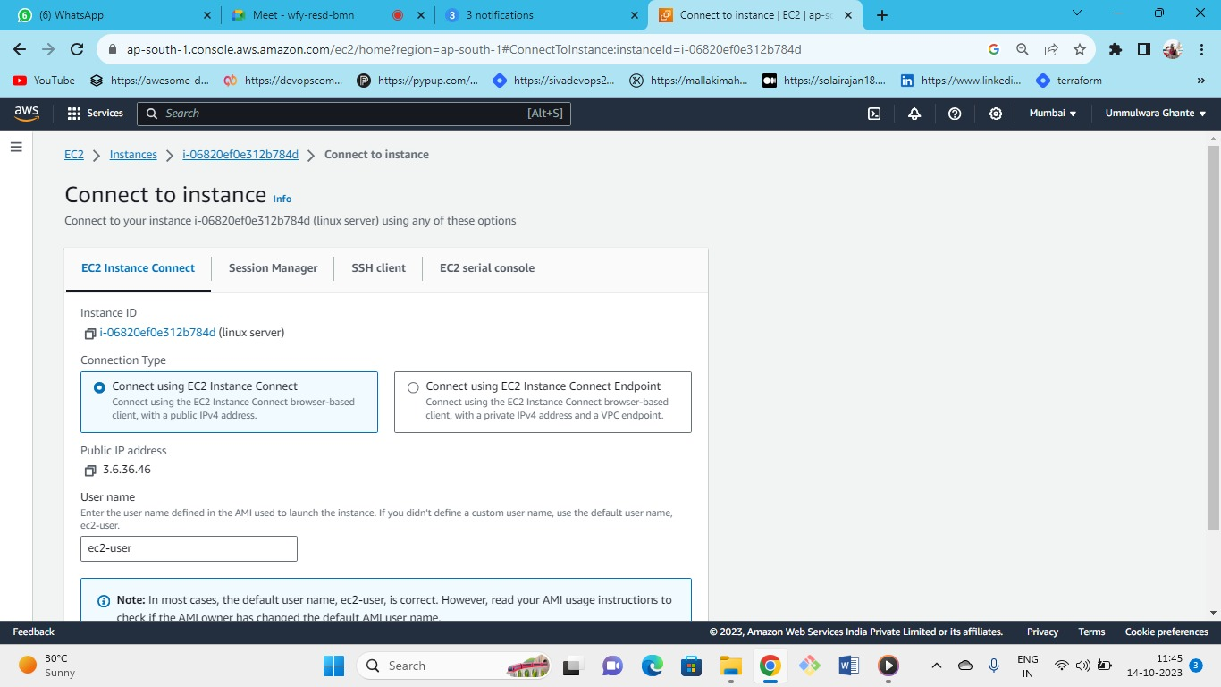connect to ec2 instance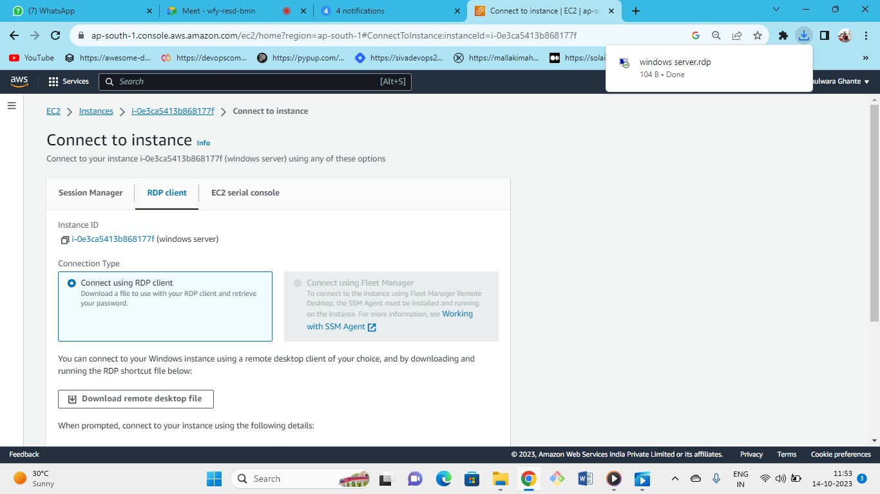



connect to windows server

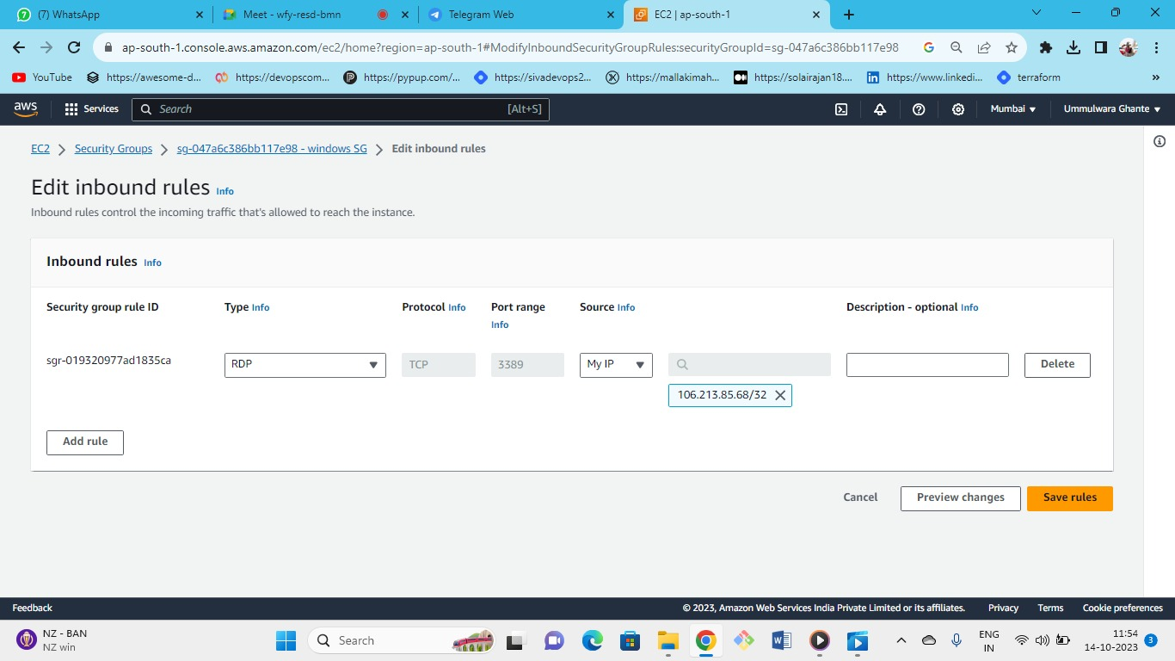



Edit the inbound security group rules for windows

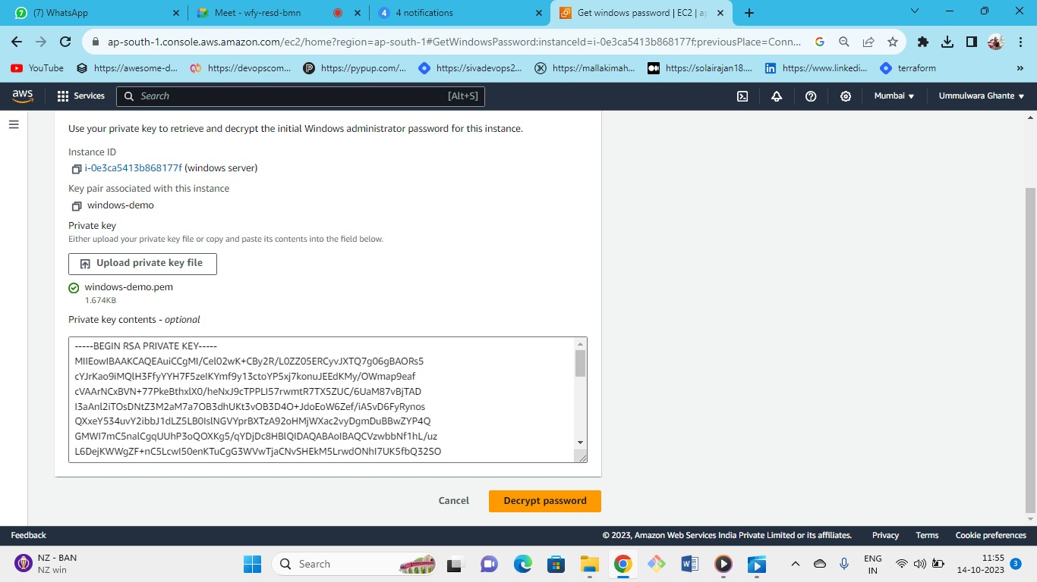



Decrypt the key and get password

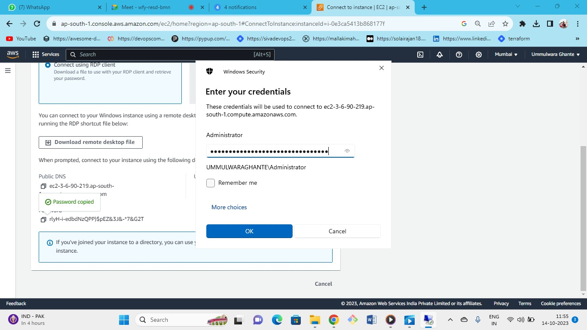



In RDP put IP/Public DNS if you use local remote desktop in your PC or else download and put the username and password

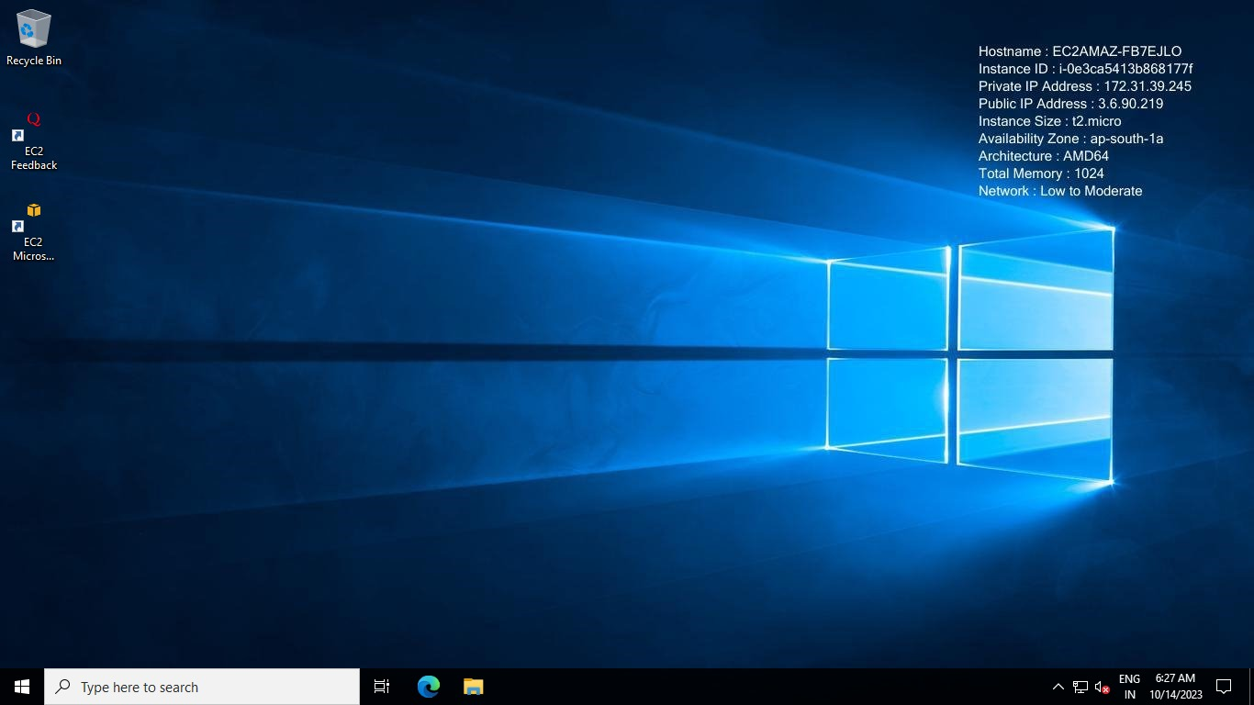

Windows instance launched successfully

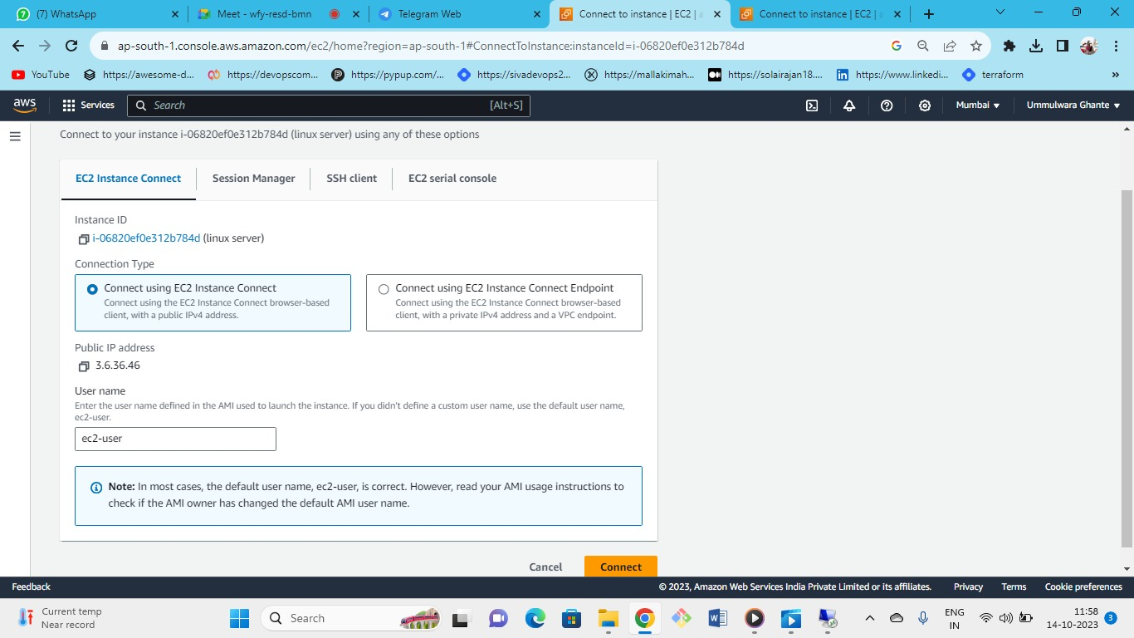



Now connect to Linux server

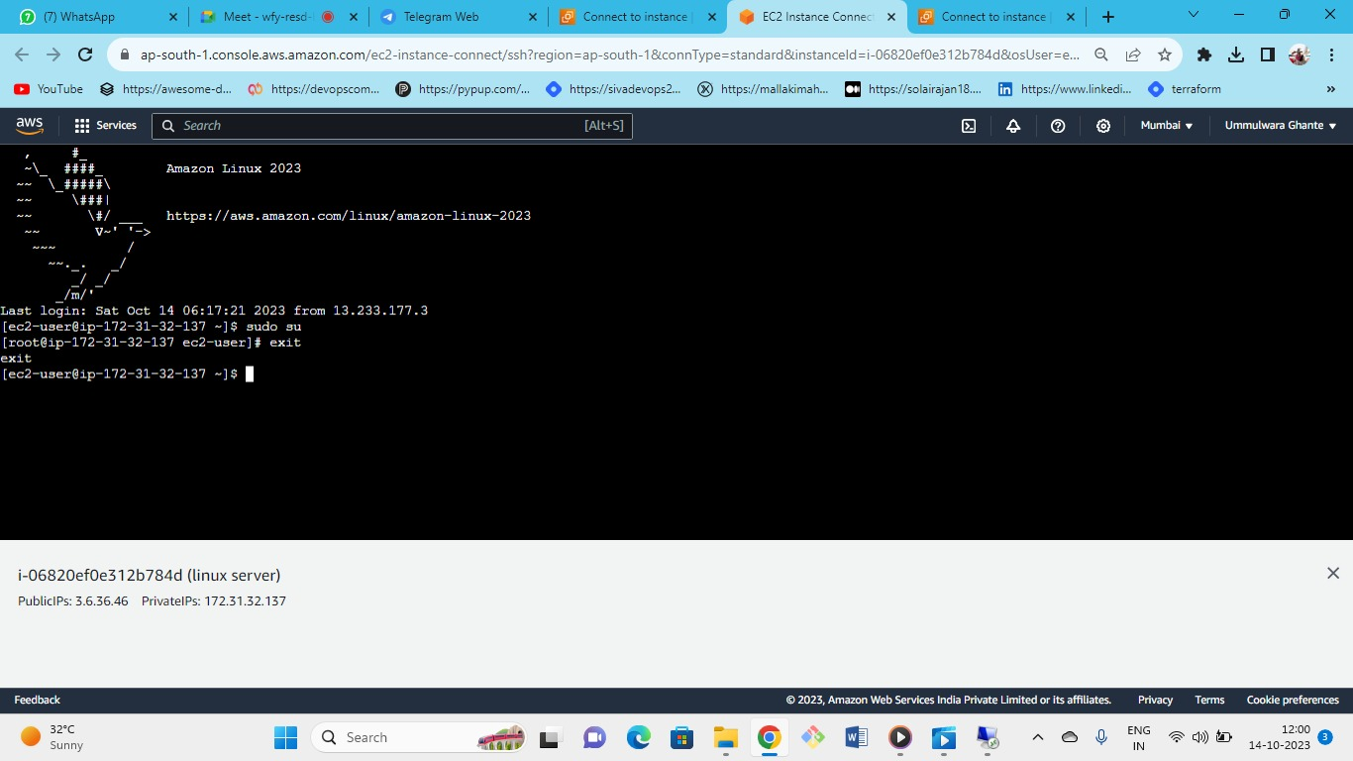



* Linux instance connected successfully
* On windows we use IIS webserver by using IIS webserver we can deliver the content to the website

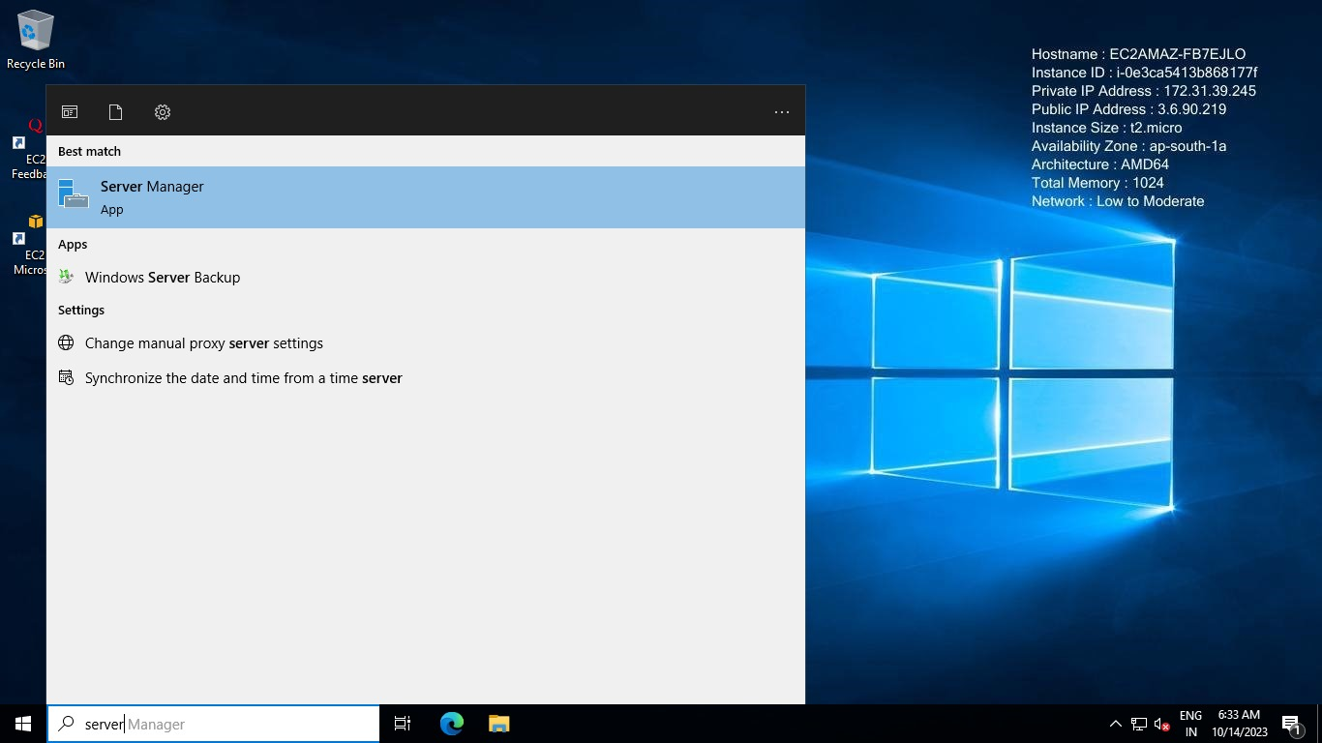

Inside windows launched instance go to the server manager

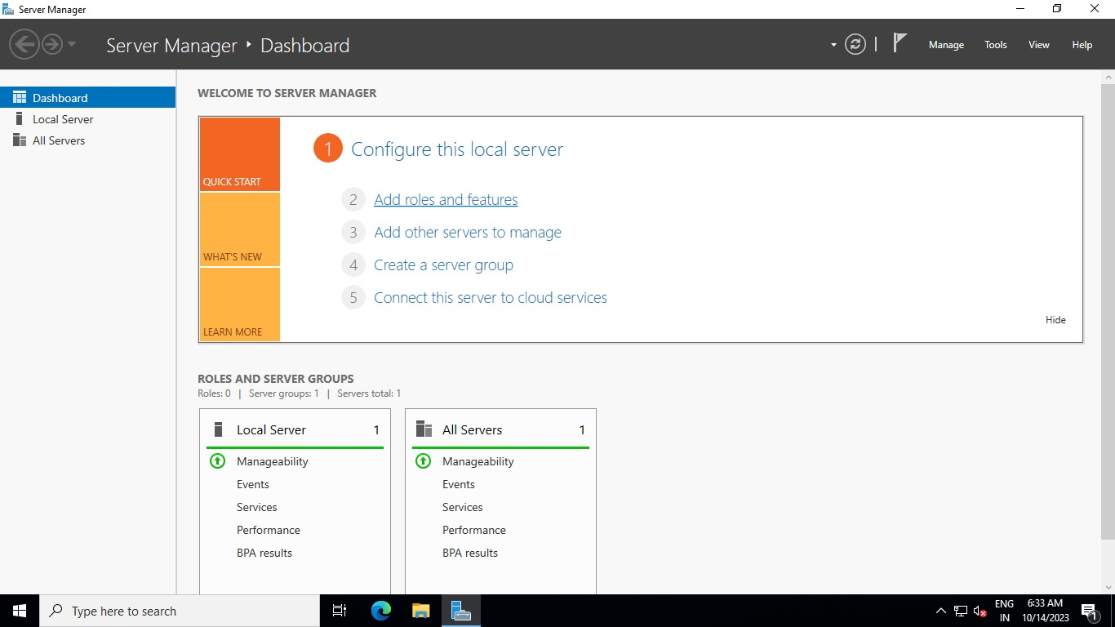In server manager add roles and features

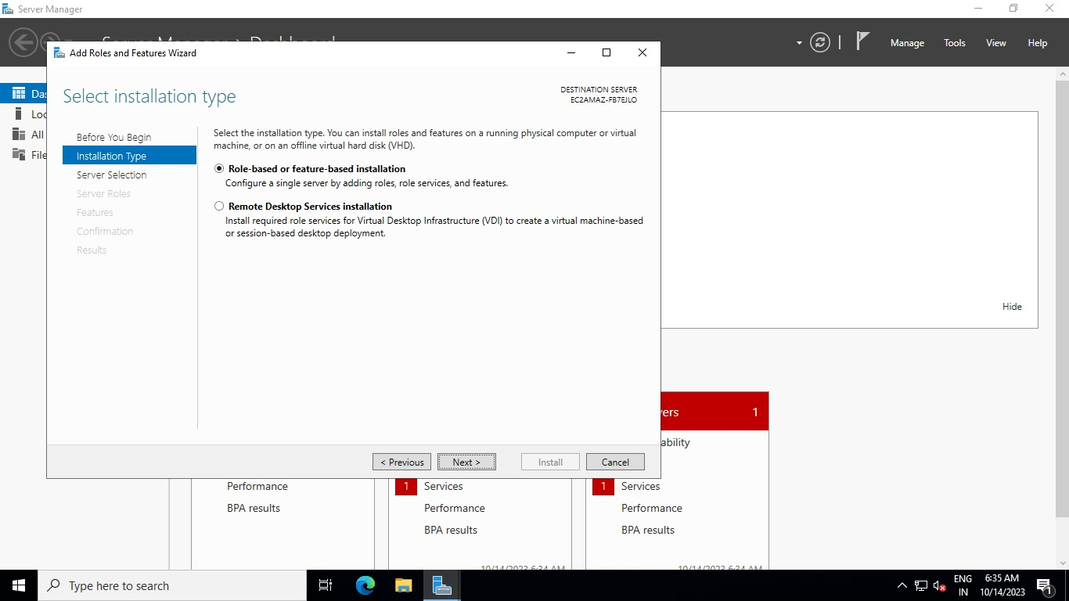

Select role based and feature based

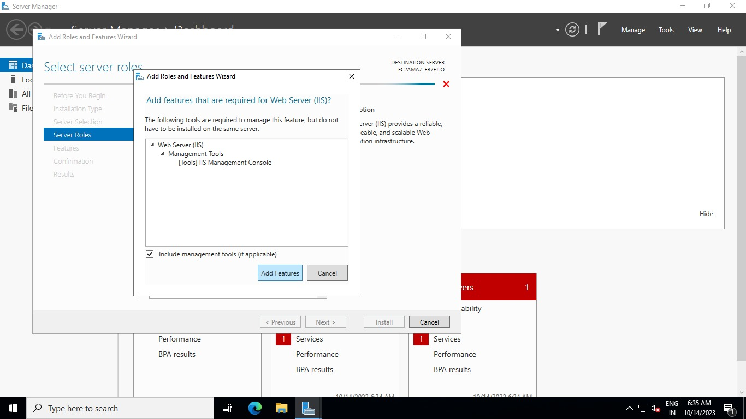

keep everything as default and add this feature as IIS webserver

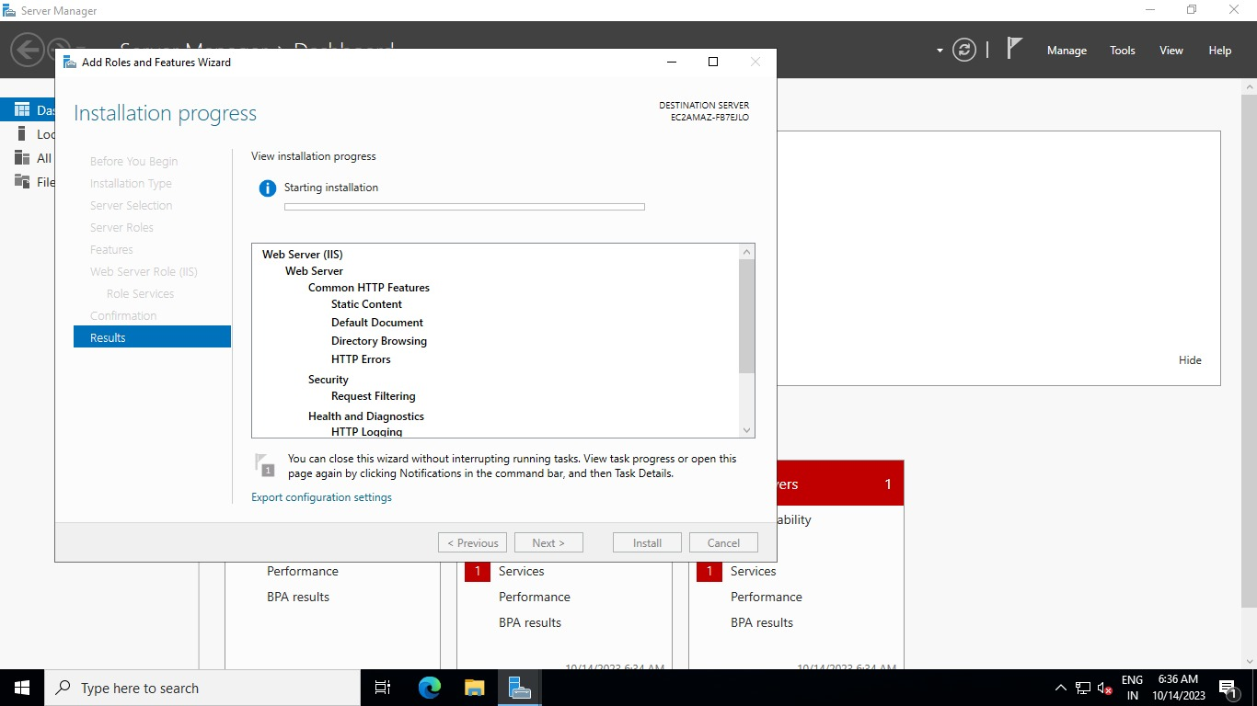

* Successfully Installed the IIS webserver
* Now come to launched linux instance we are going to install Apache (i.e., HTTPD) on Linux instance

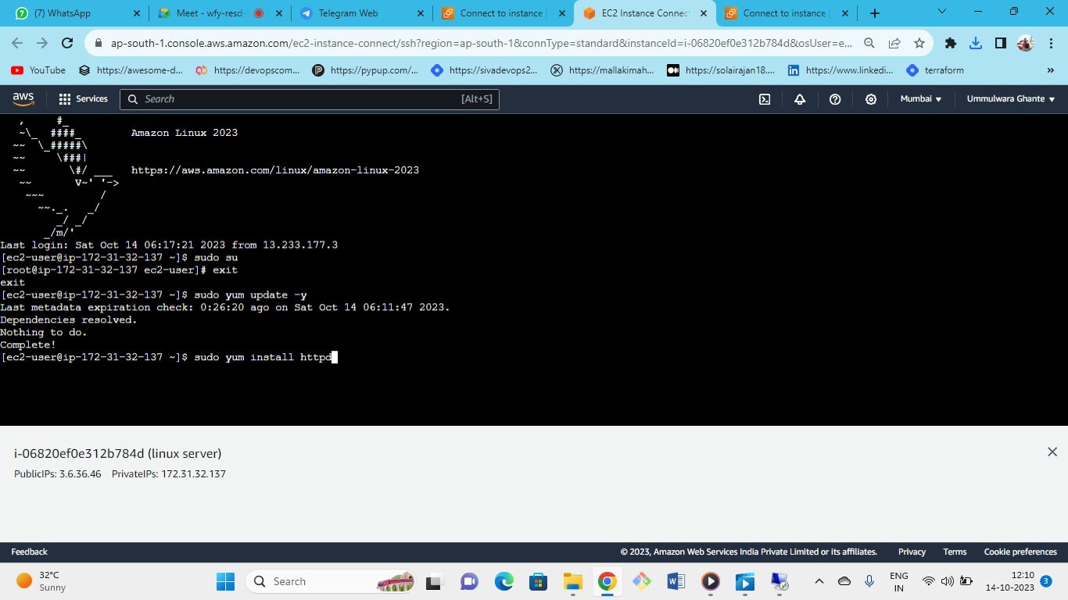



First check for updates and then install the Apache server

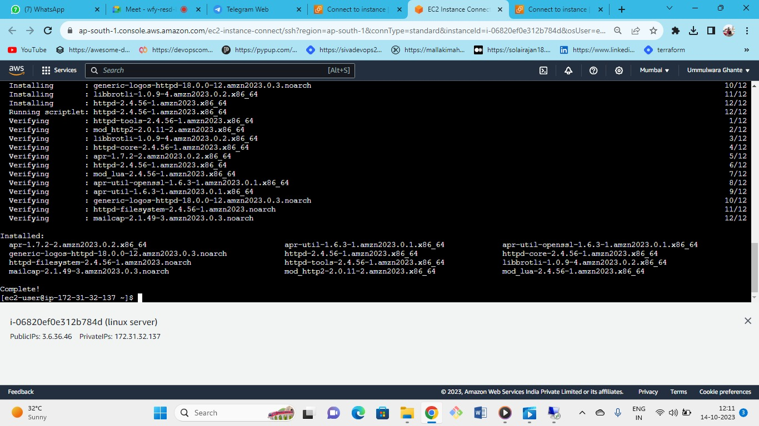



check that server is install or not

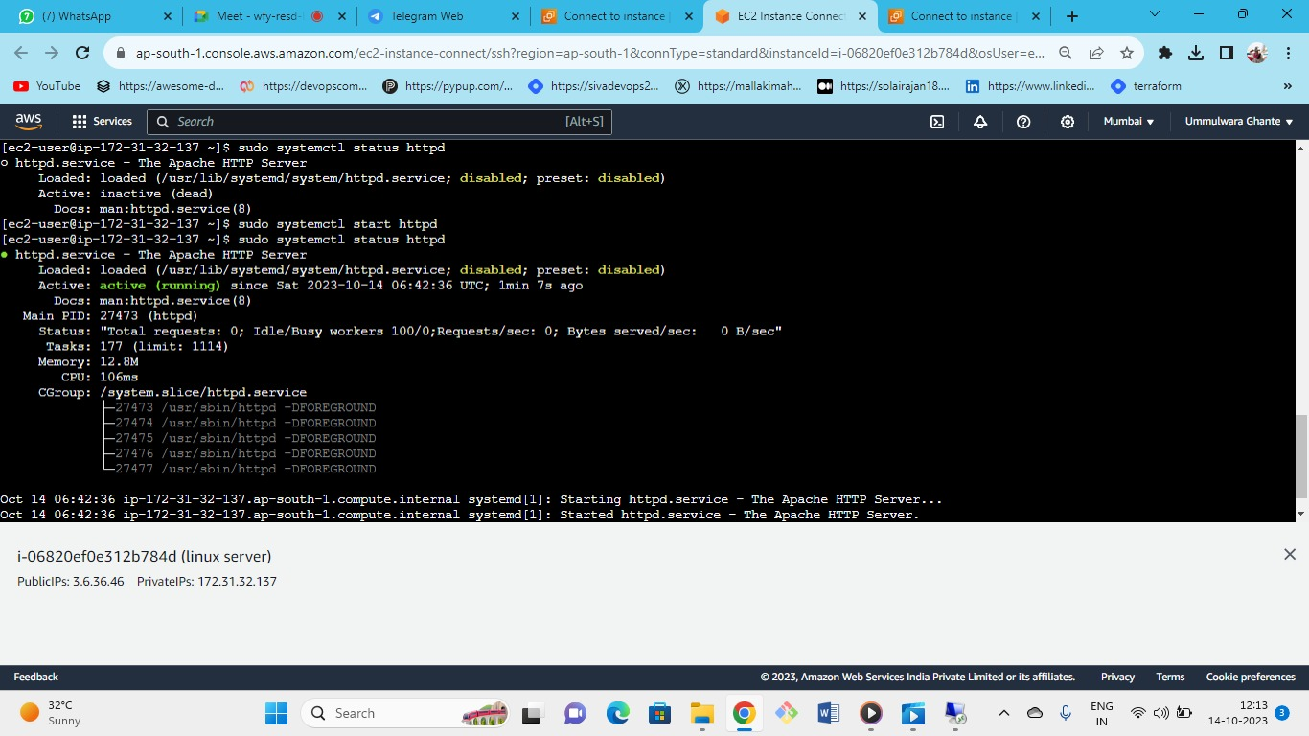



whenever we install the Apache webserver it create a folder structure where we can put our website

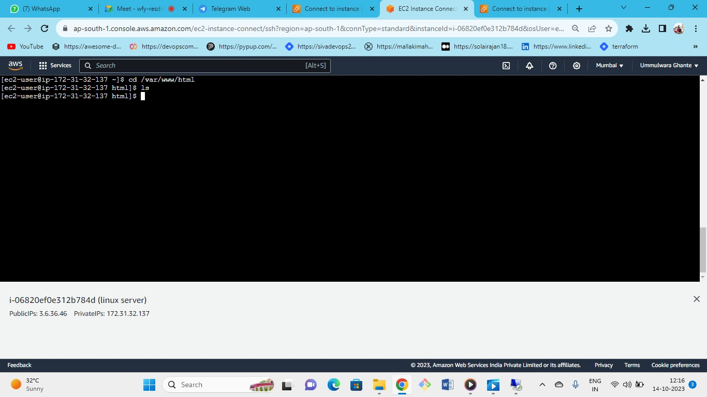



this is the folder structure

whatever the file we will keep will deliver as web pages

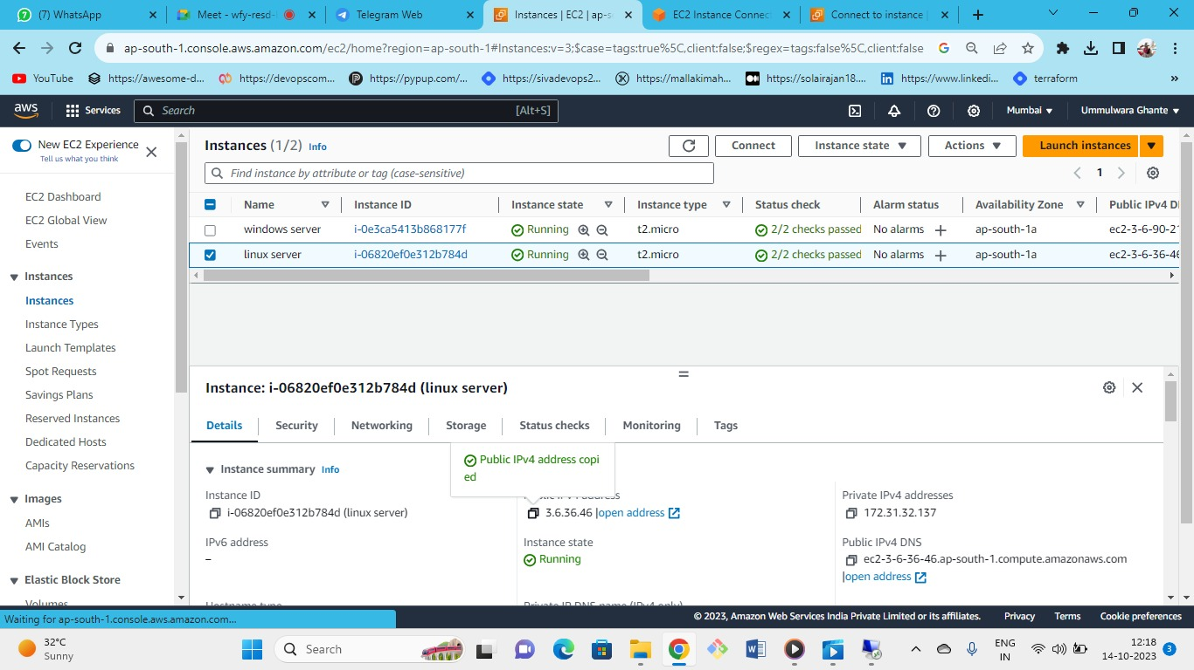



take public IP and check

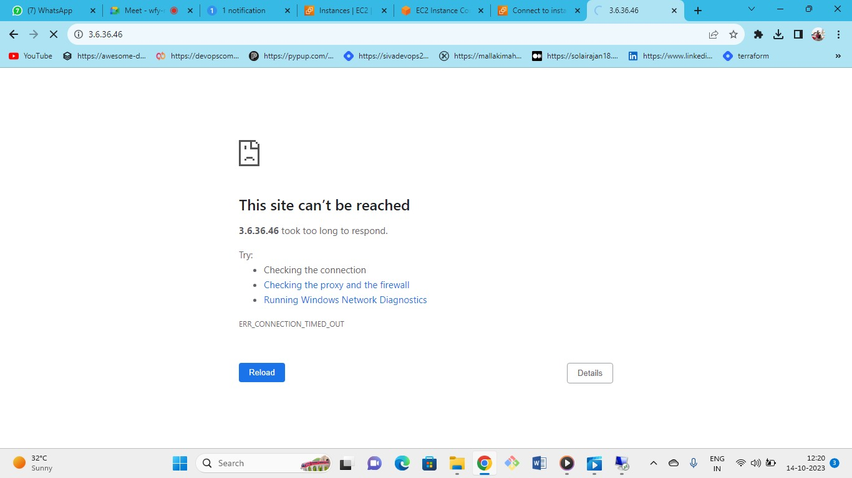

as we got this error cox we need to add http port in security group

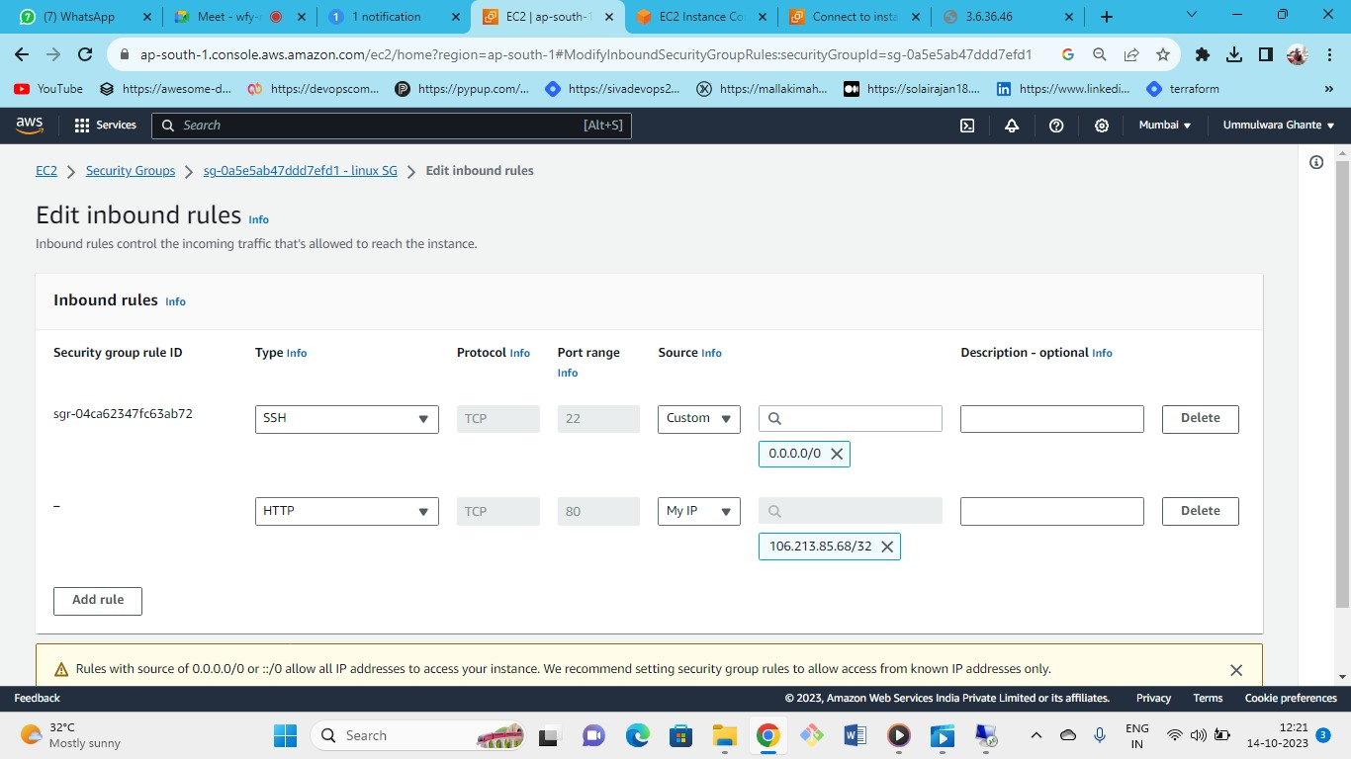



In SG select HTTP and give permission for MYIP in the inbound rules

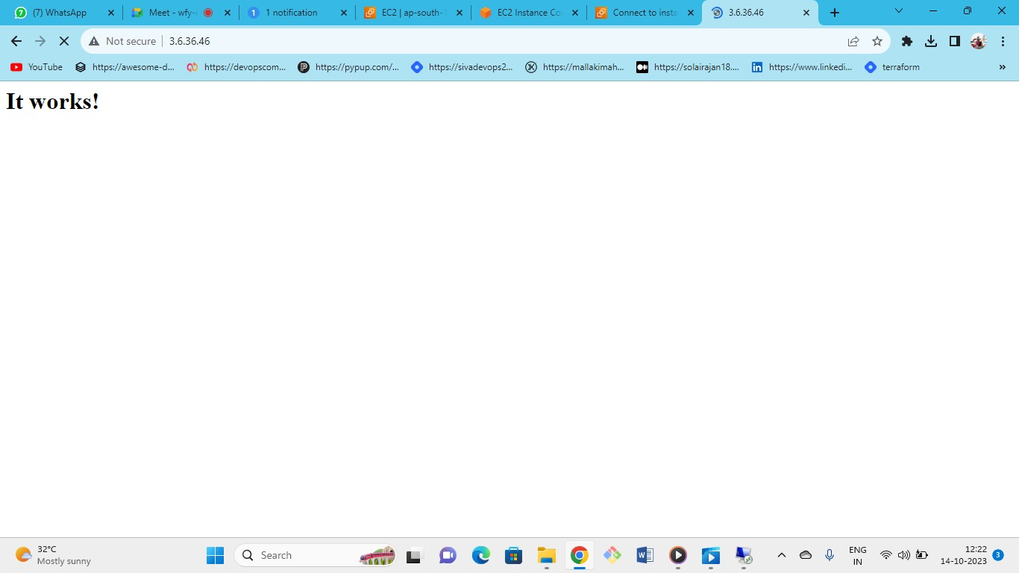



As we can see now its working

But as we can see this is a default webpage by AWS to create our own webpage use following steps

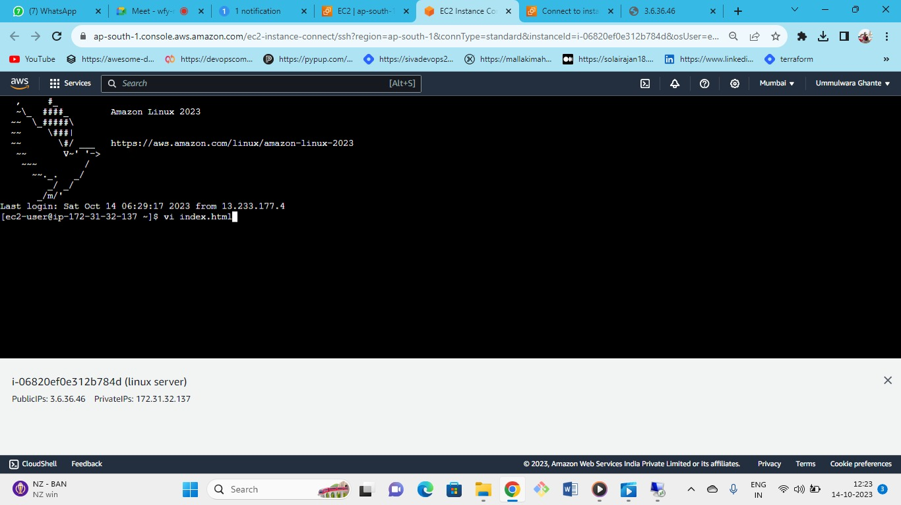



By entering this command press i for insert

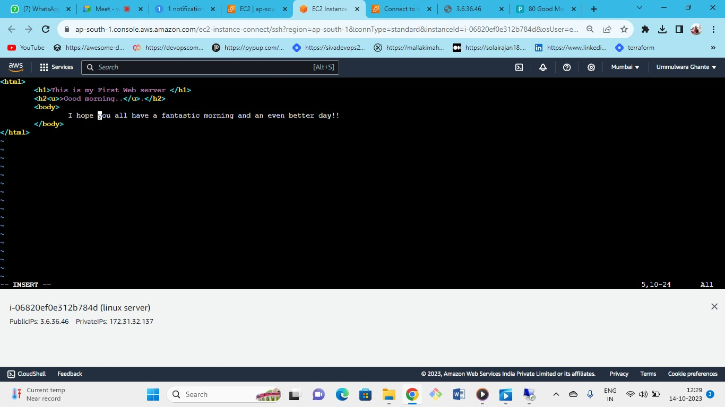



Enter the contents which you want in your webpage

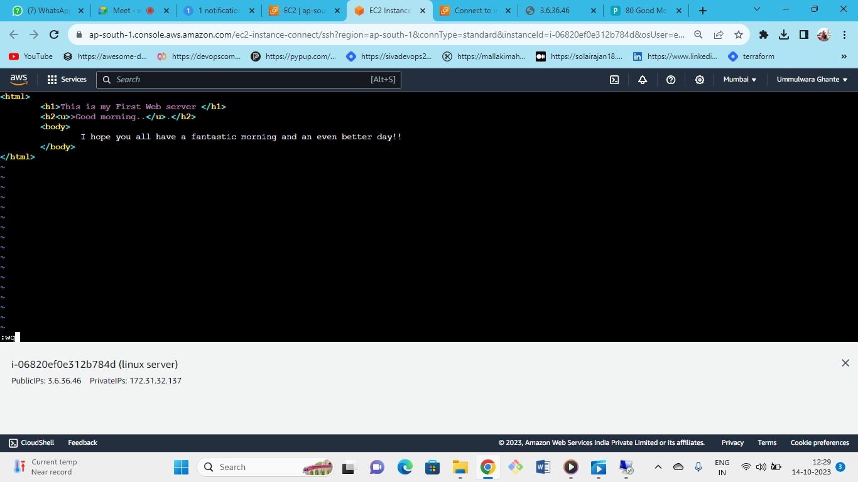



just press esc and shift+: =(:wq)

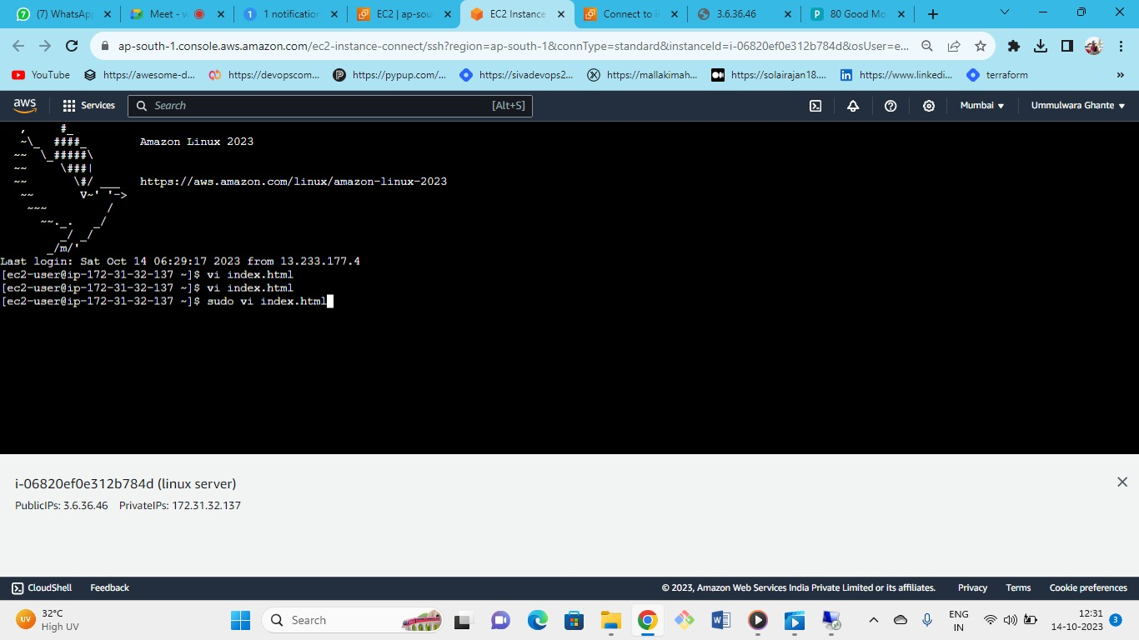



The following changes will not work because to make changes we require admin permissions so use sudo and the command

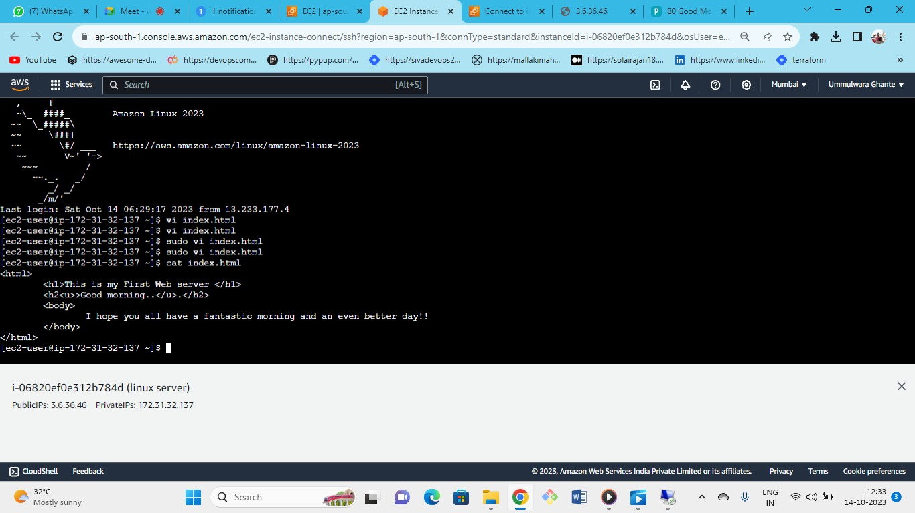



To read the file use cat command

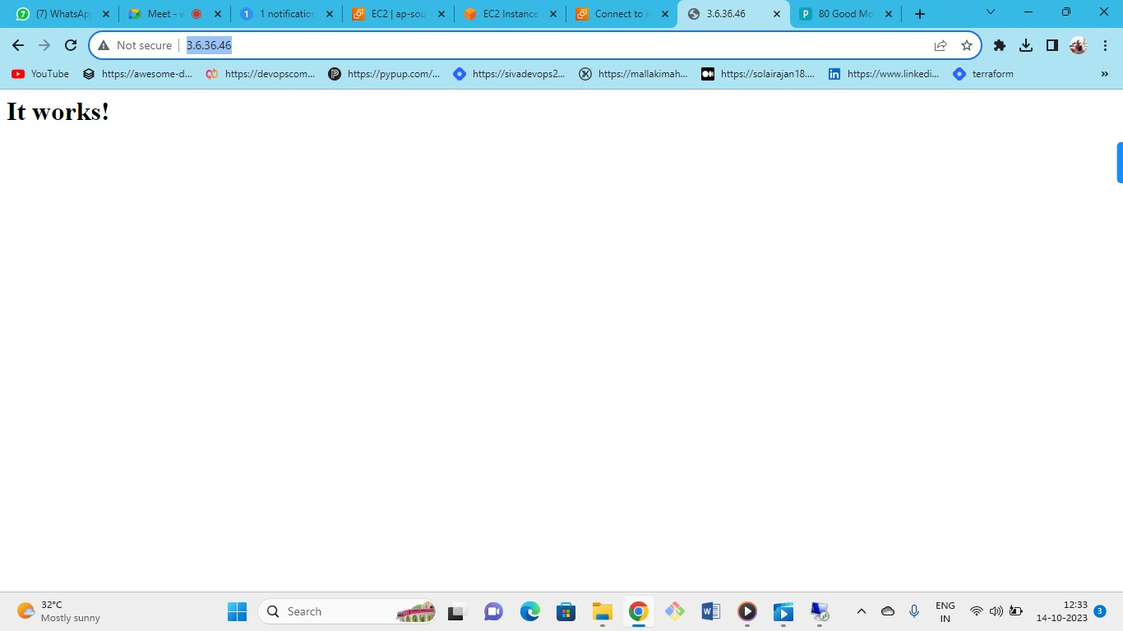



now press enter see is it work?

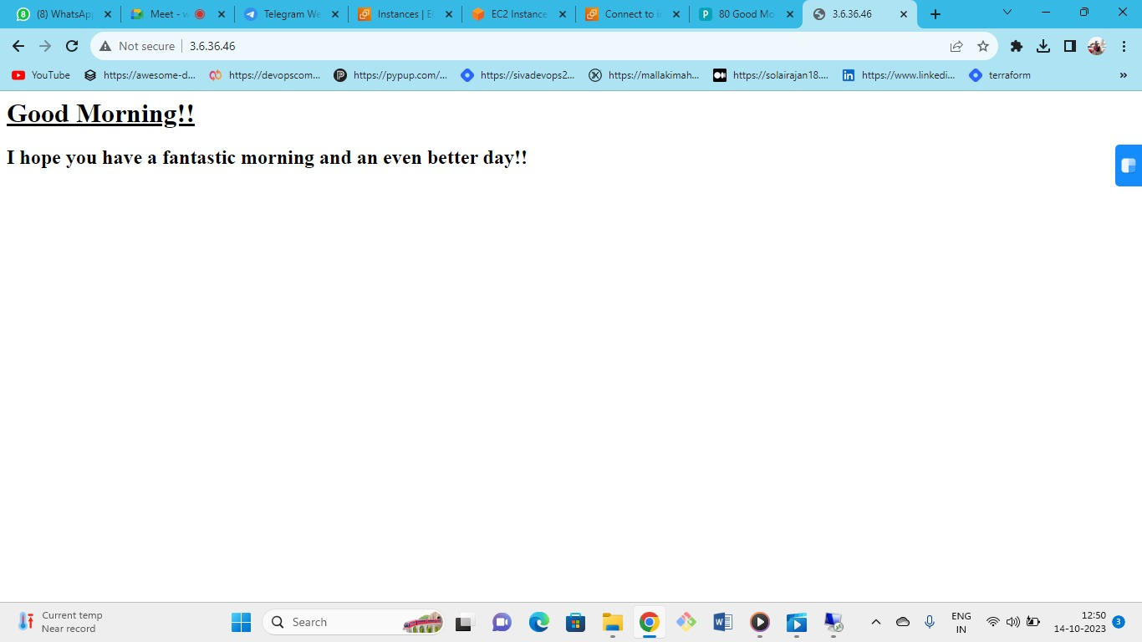



This is about Apache server

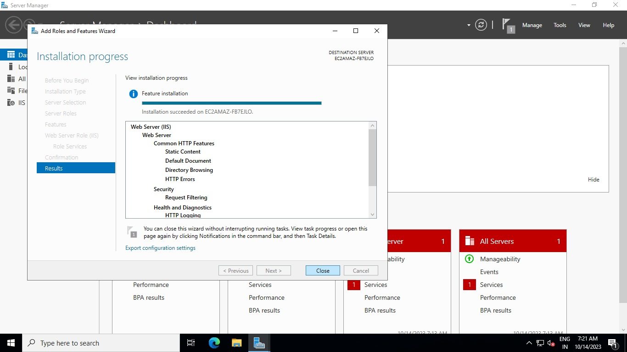

Now coming on to windows server

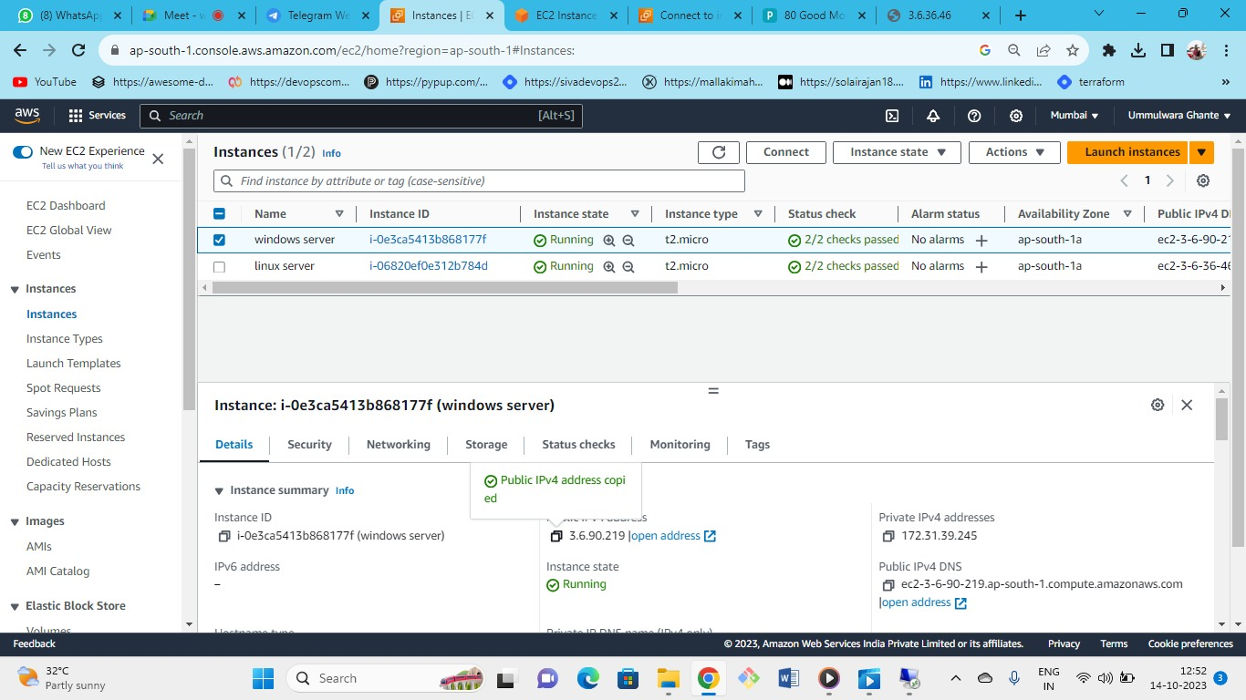



Copy the public IP and check for default page

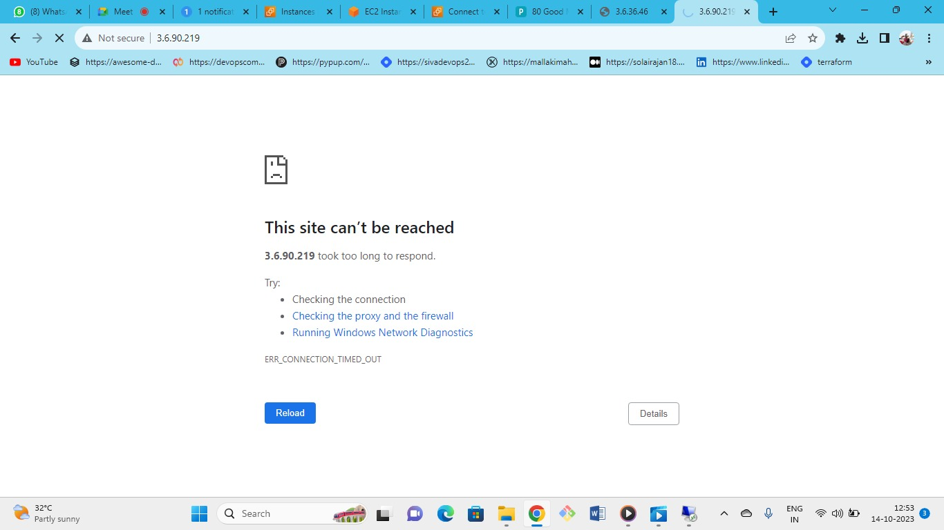



Not available allow port 80 in security group

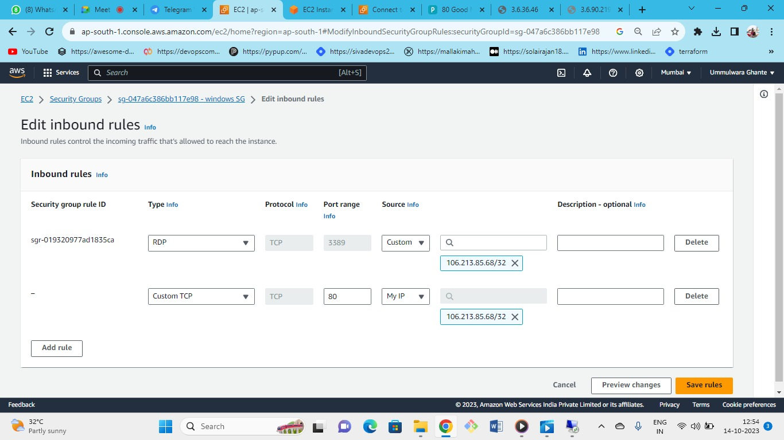



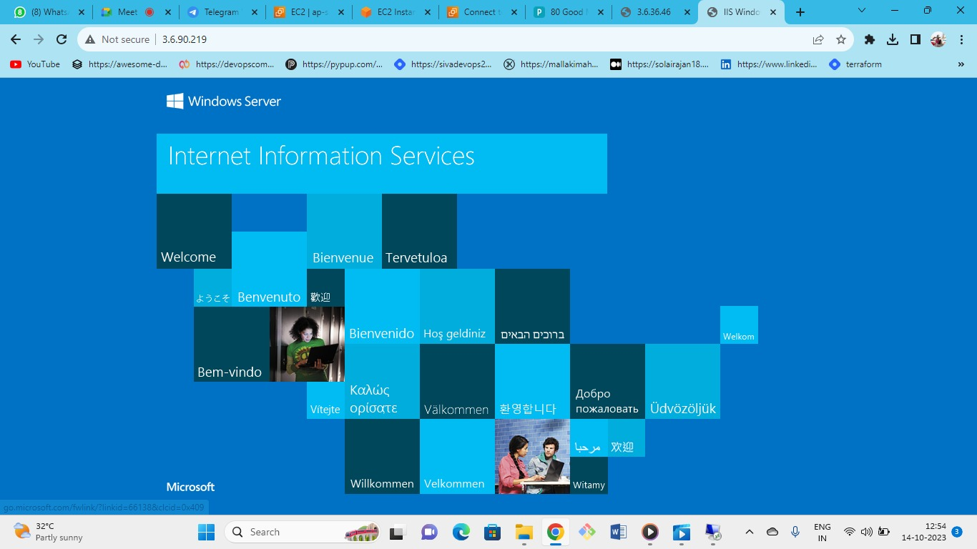



Now the default page is available

Now let’s attach the volume to the instances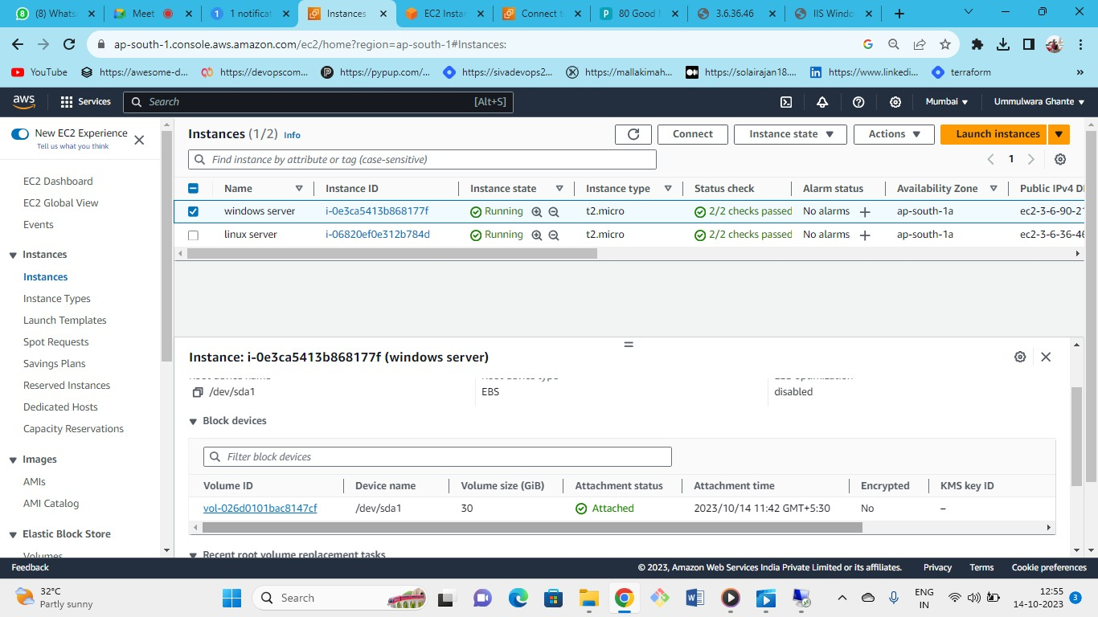



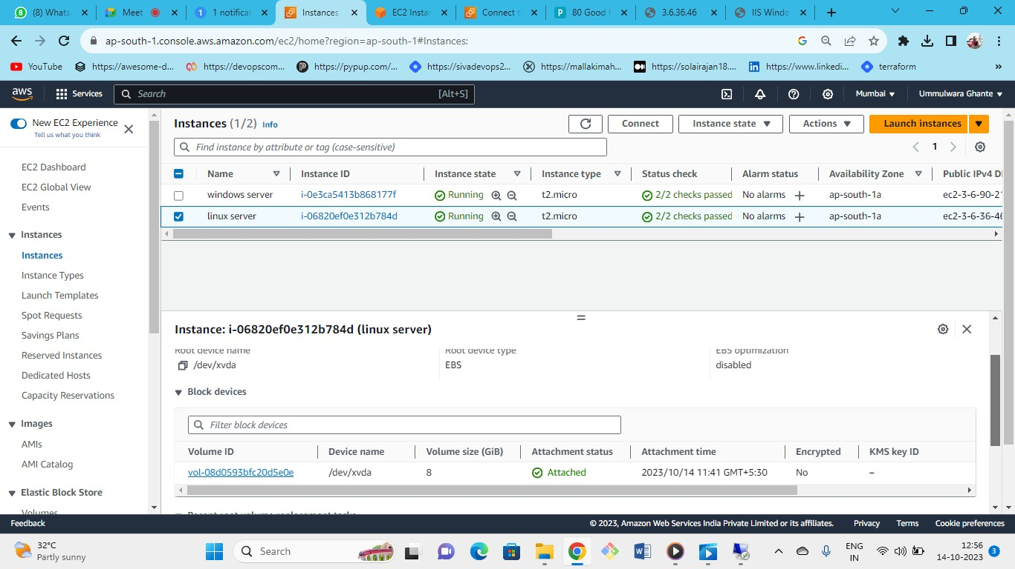



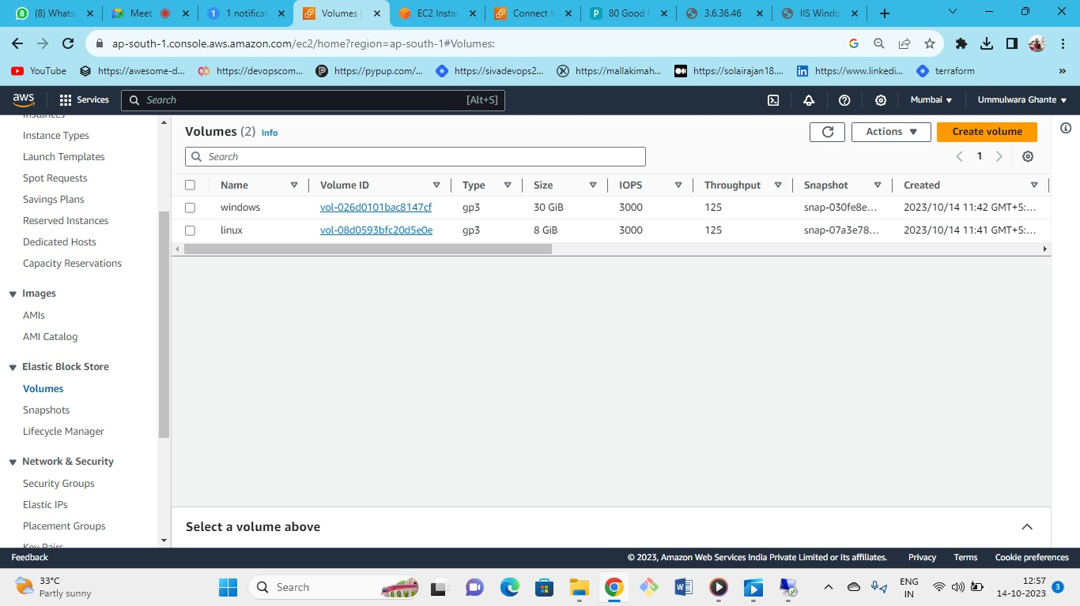



Go to volumes and create new volume

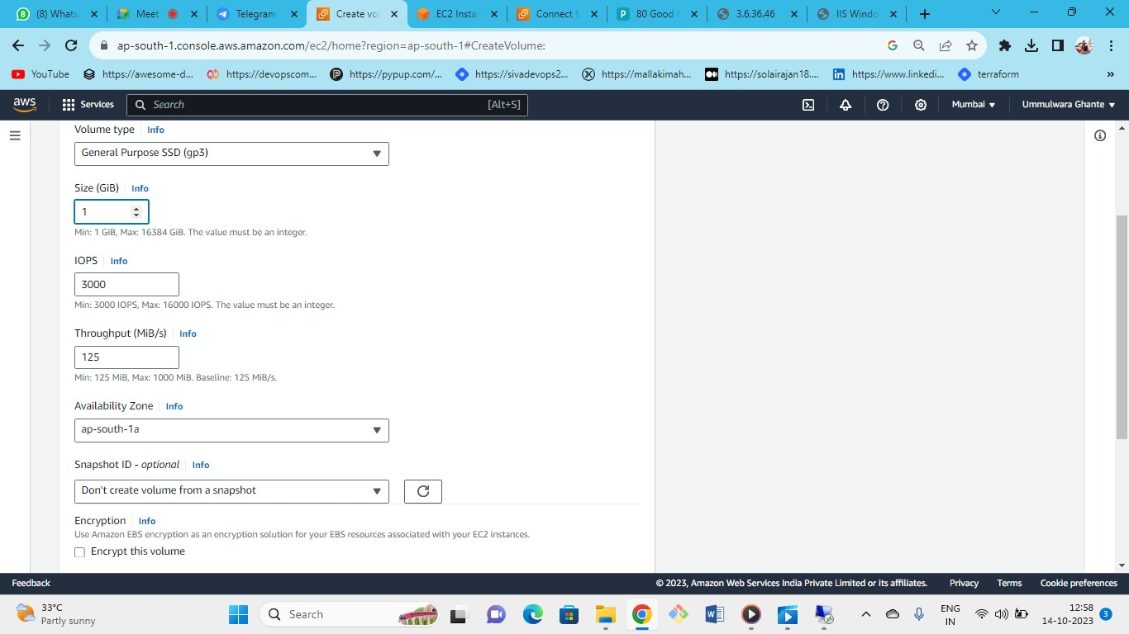



Select the specifications you want (gp3,1GB etc)

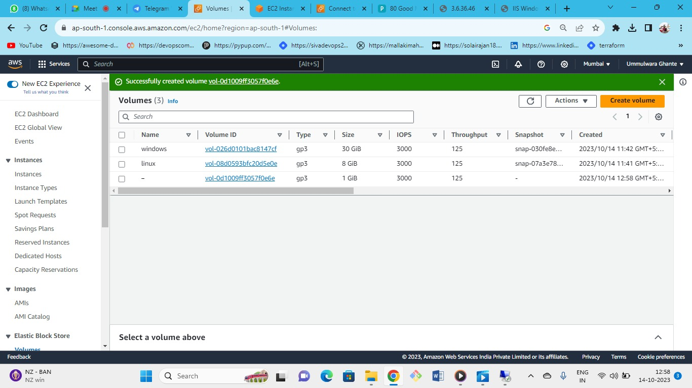



New volume has been created now attach this volume to windows instance

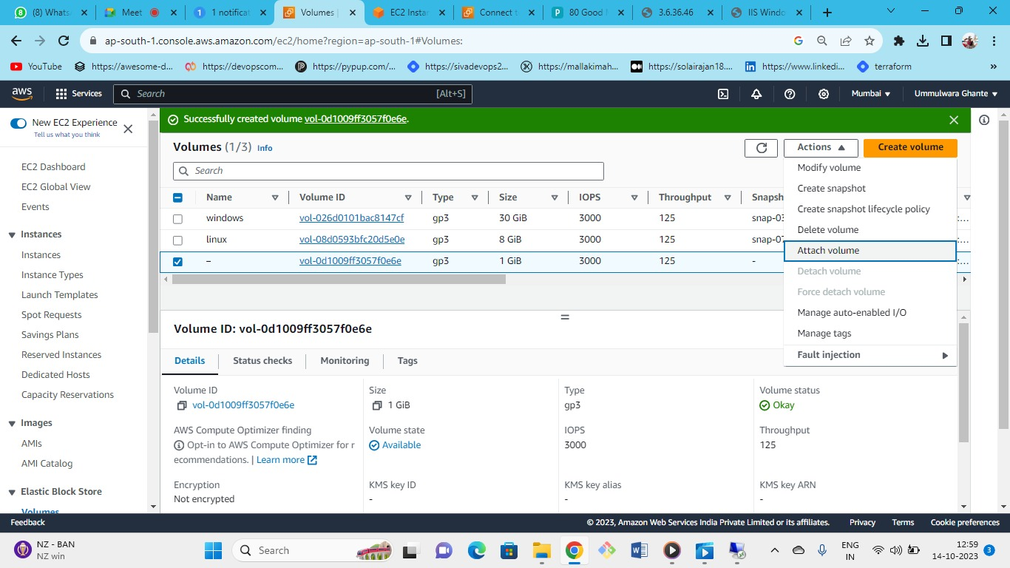



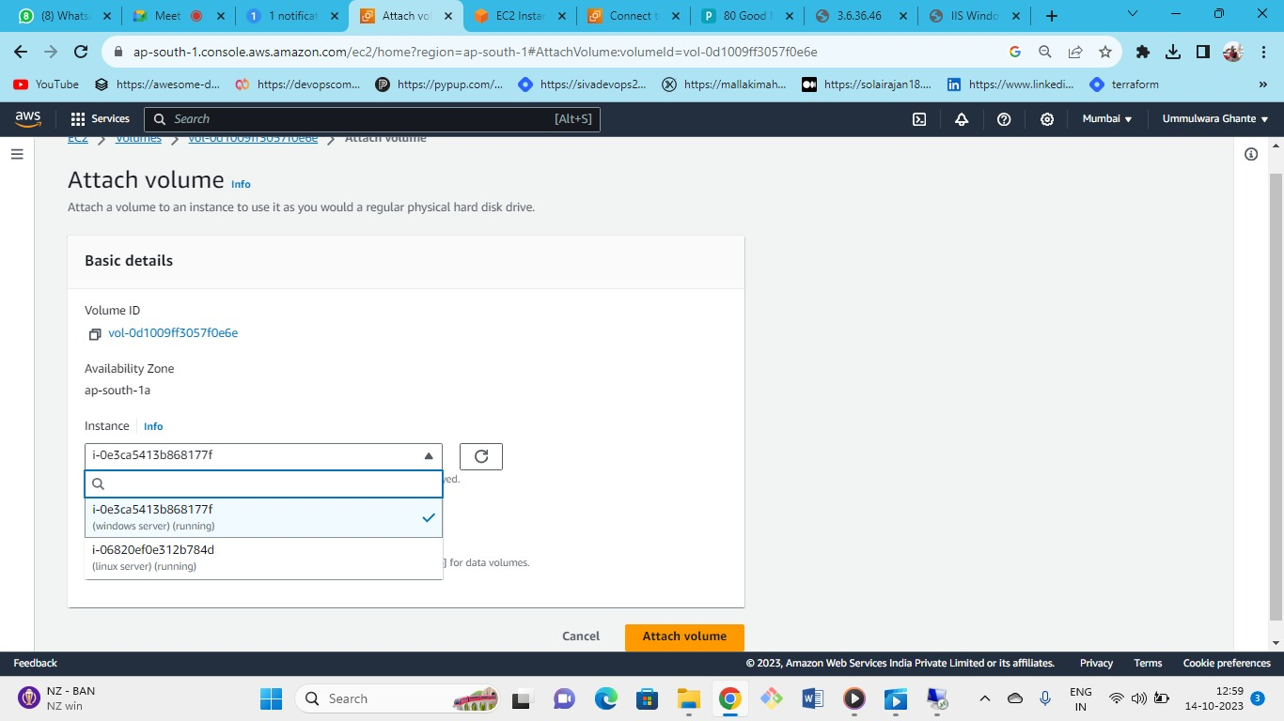



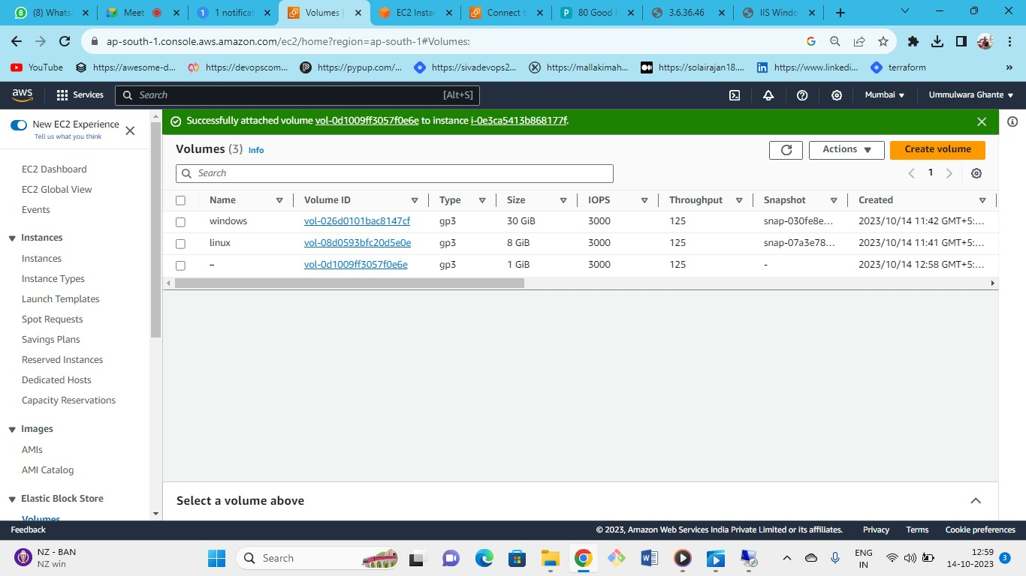



Volume has been successfully attached to the windows instance

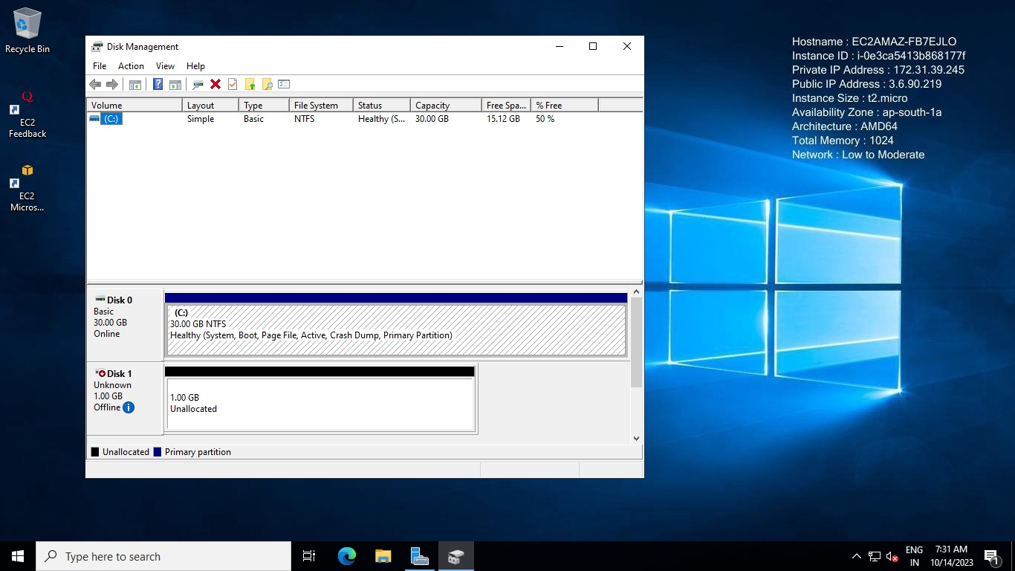

Now go to launched windows instance and type (Windows +R) 🡪 diskmgmt.msc

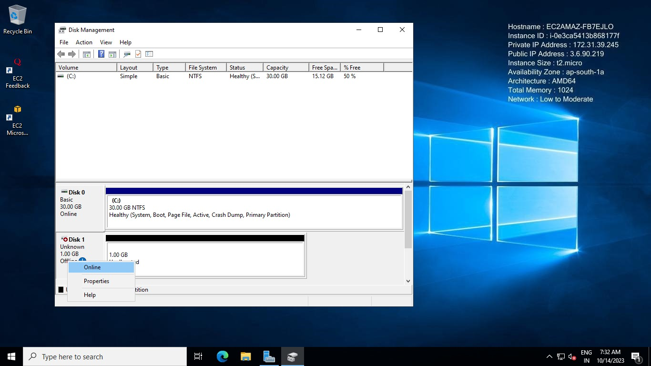

As we can see 1GB is not allocated over here and it is offline so first to allocate it we need to make it online

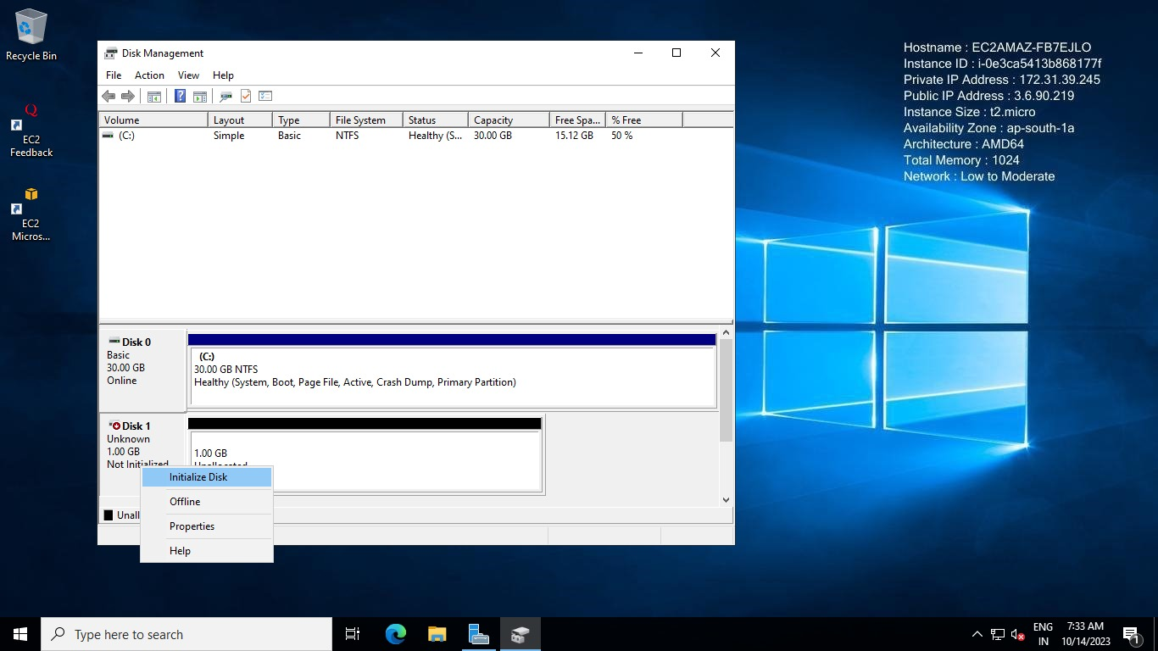

Now we need to initialize the disk so right click on it and initialize (select MBR or GPT as per your choice here we have kept everything default) and hit enter

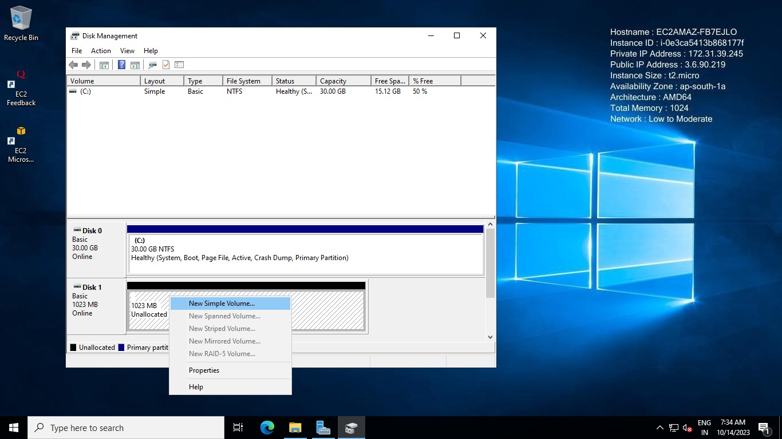

Right click and select new simple volume just click next keep everything as default

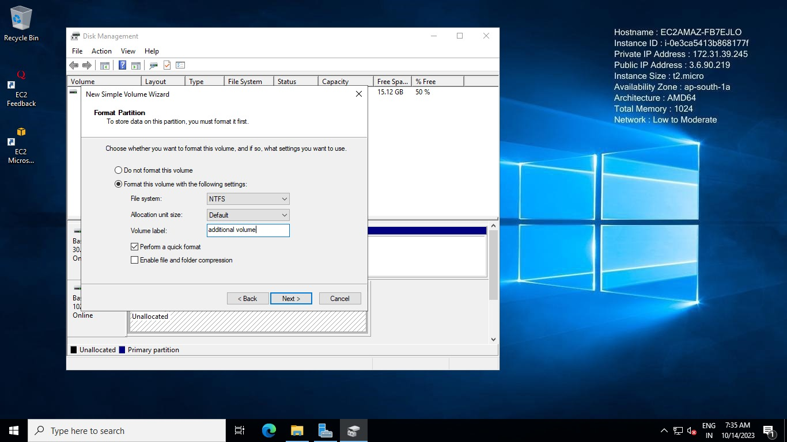

give this as title and keep other setting as default (give the volume name if you want)

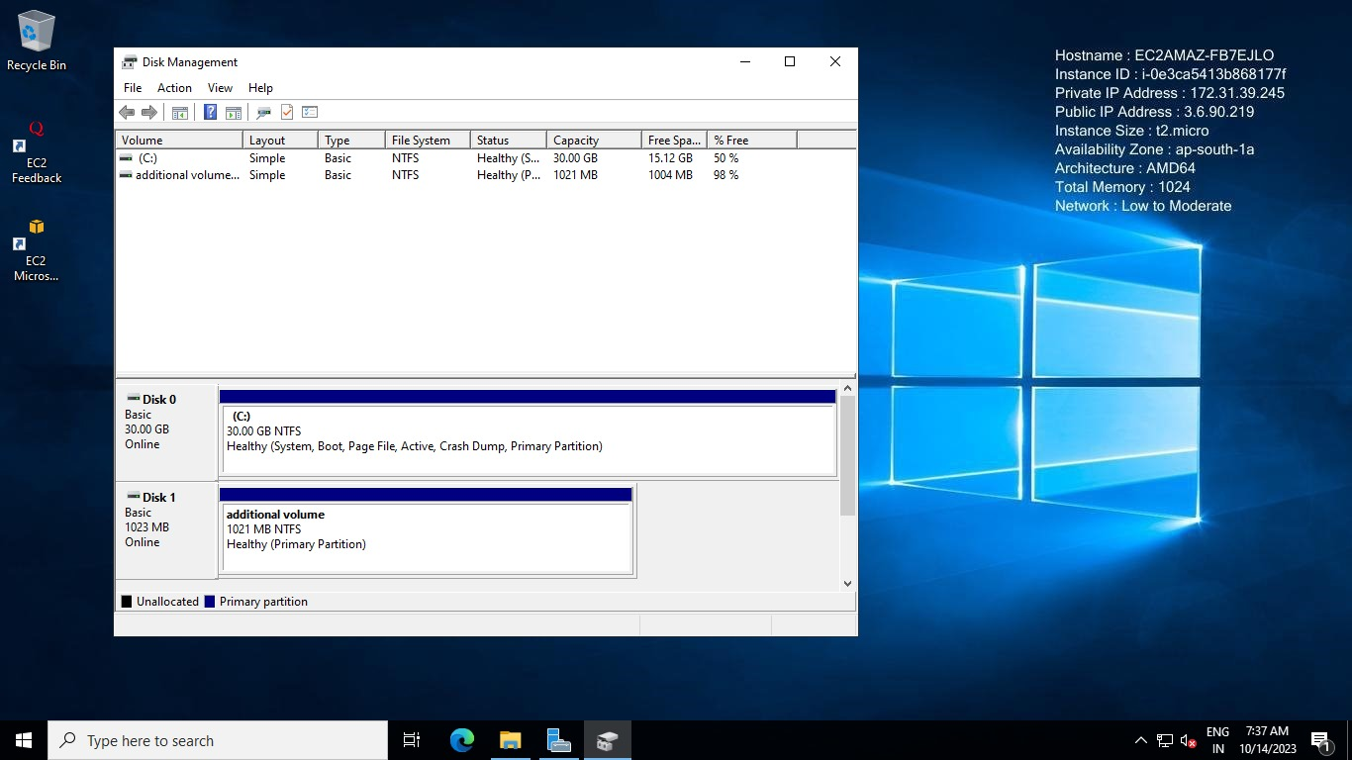

Now our volume has come to healthy state

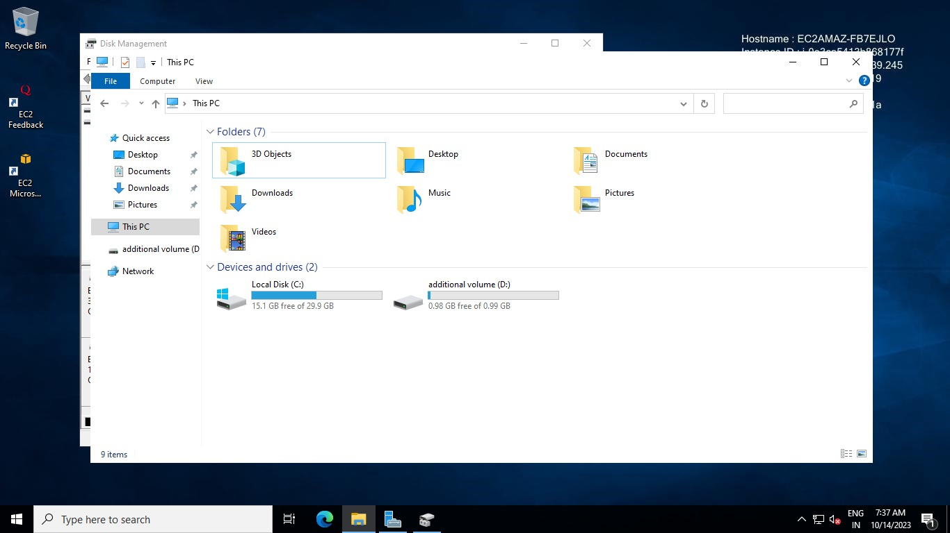

As we can see we have got our additional 1GB volume

Now suppose we have and additional demand to increase the new volume created so we can modify our volume

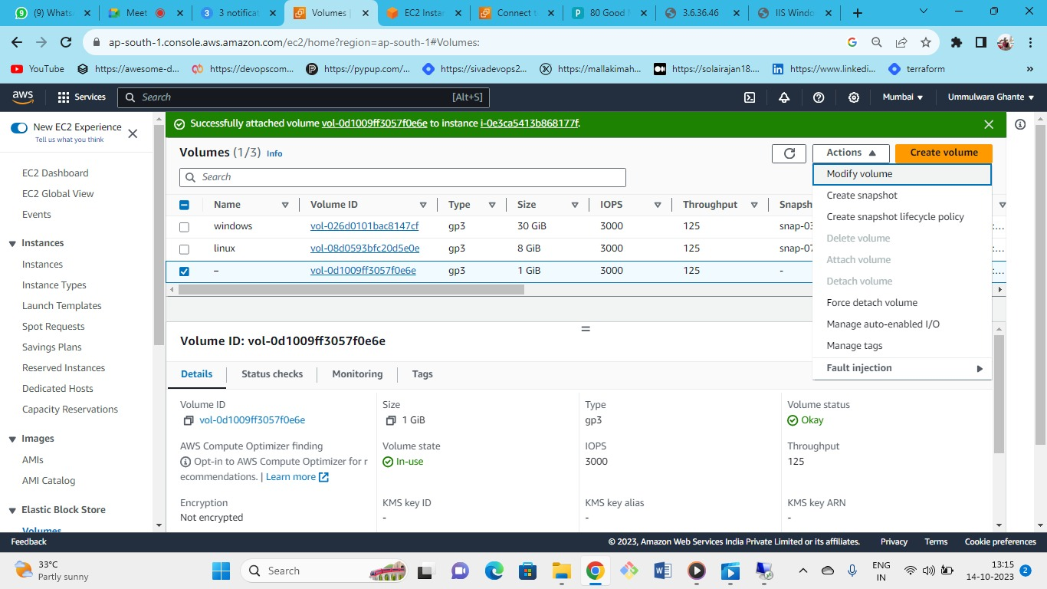



as when we need to extend the volume

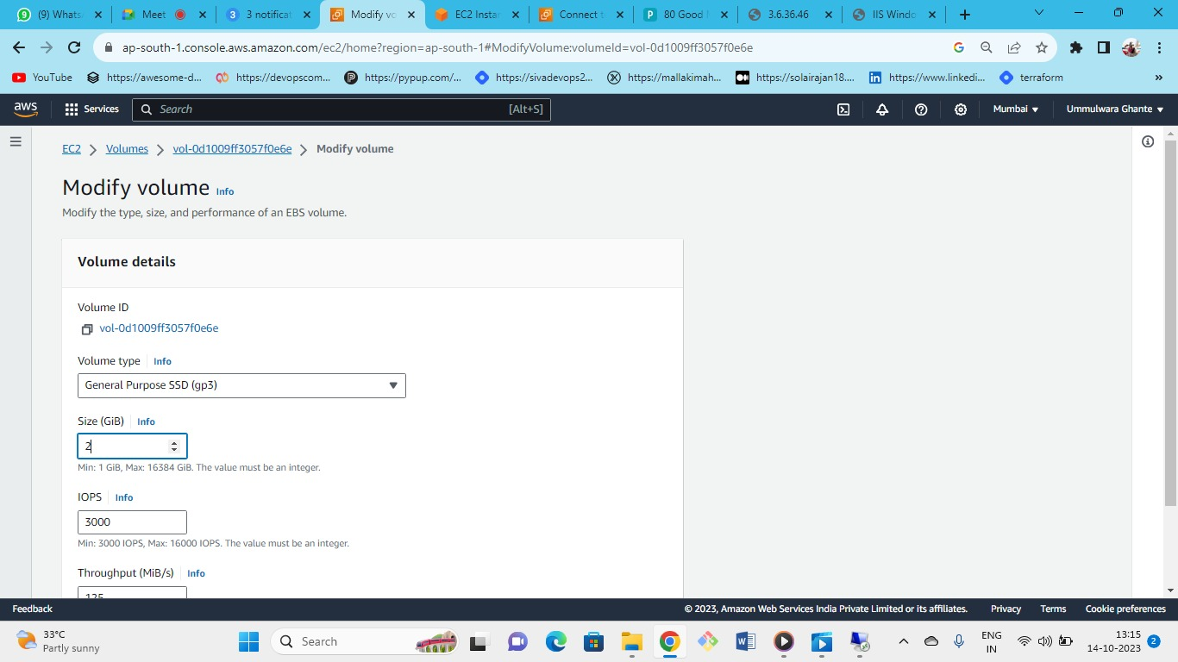

Increase the volume which you want

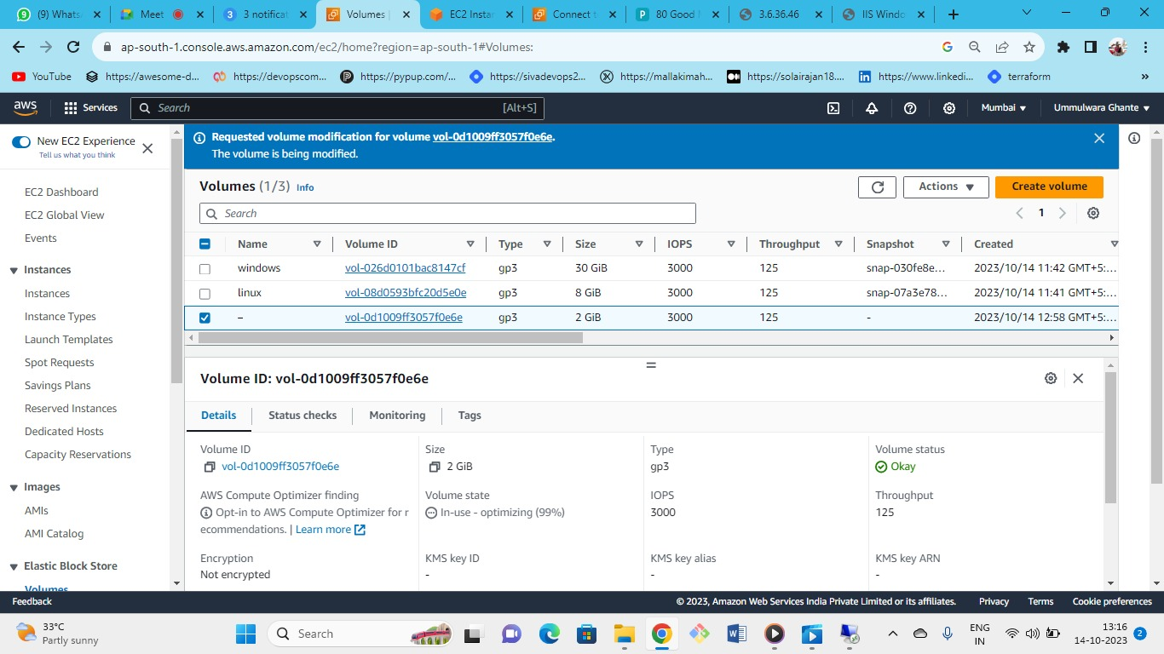



New volume modified

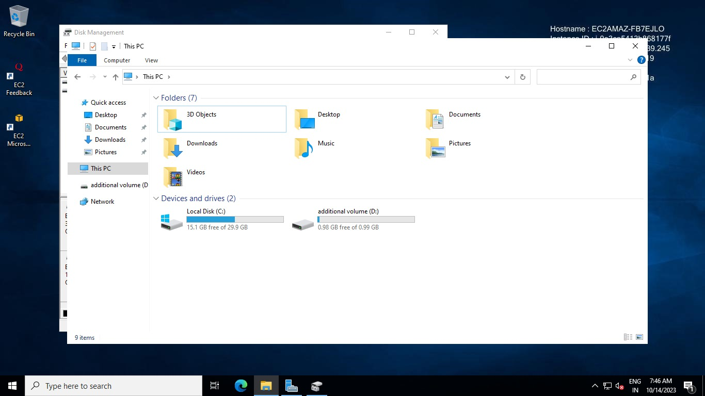

Now we have modified the new volume but still its not available here we need to do that

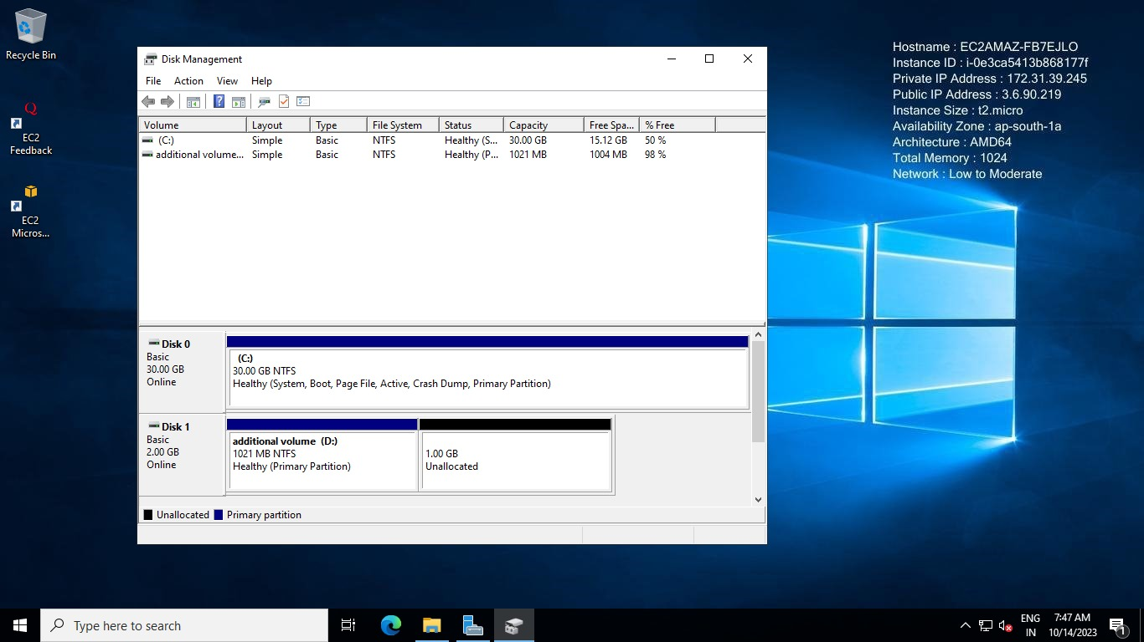

Go to (Windows+ R🡪diskmgmt.msc) As we can see the new additional volume is unallocated

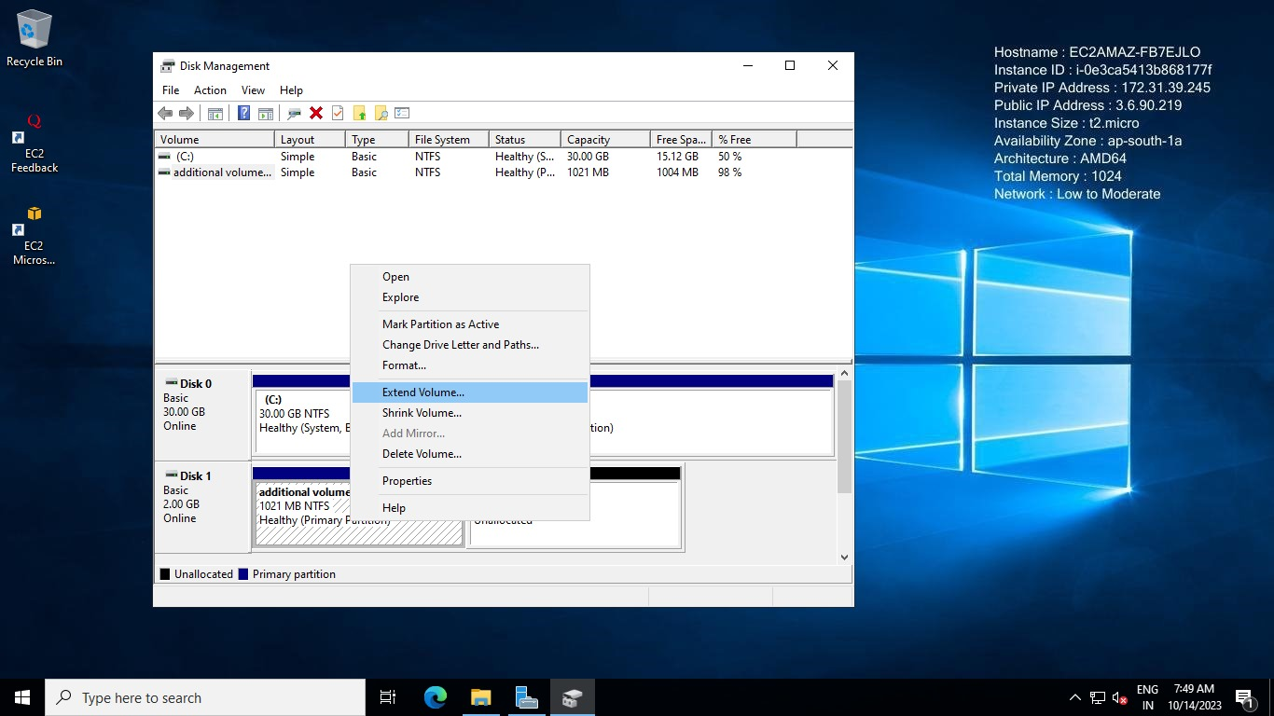

So right click on the previous volume and select extend volume

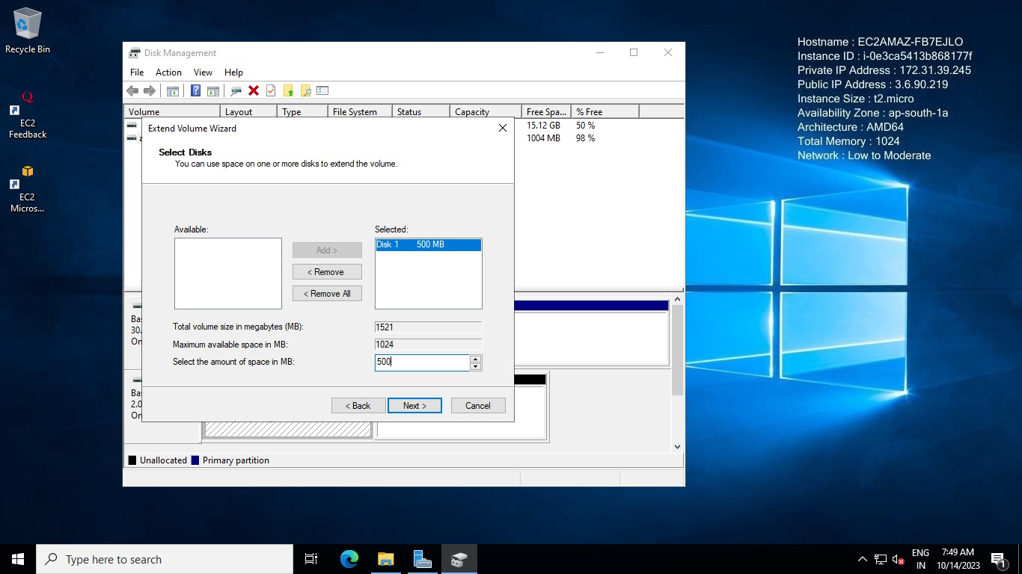

Select the amount of volume you want to attach out of additional 1GB

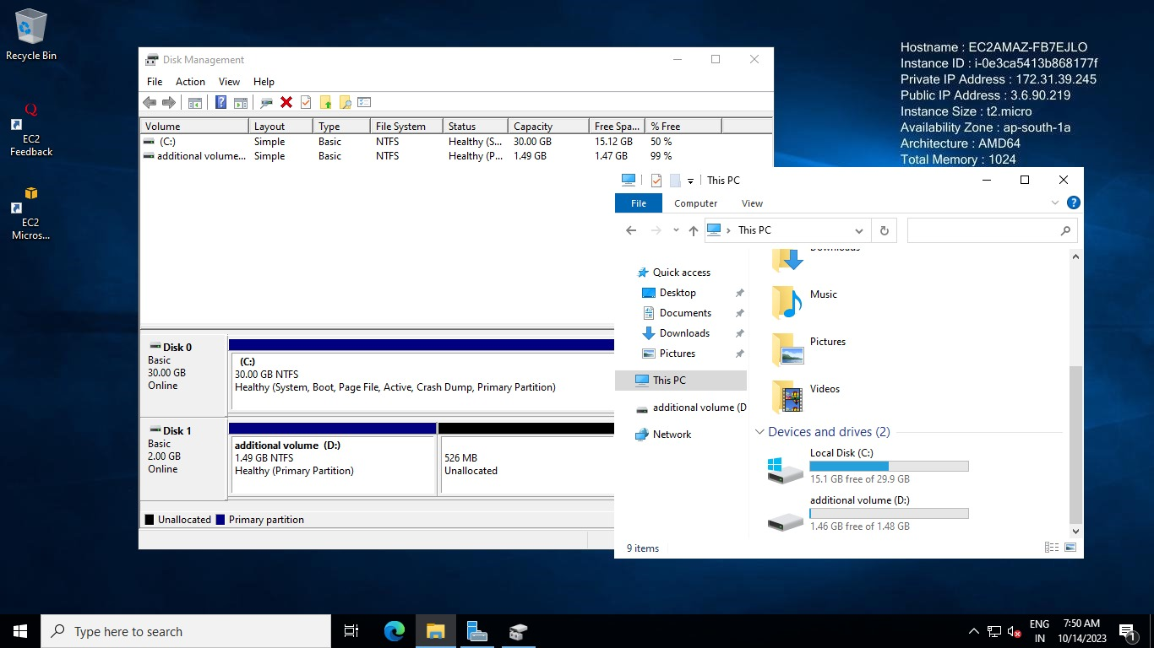

As we can see we have our 1.49GB additional volume

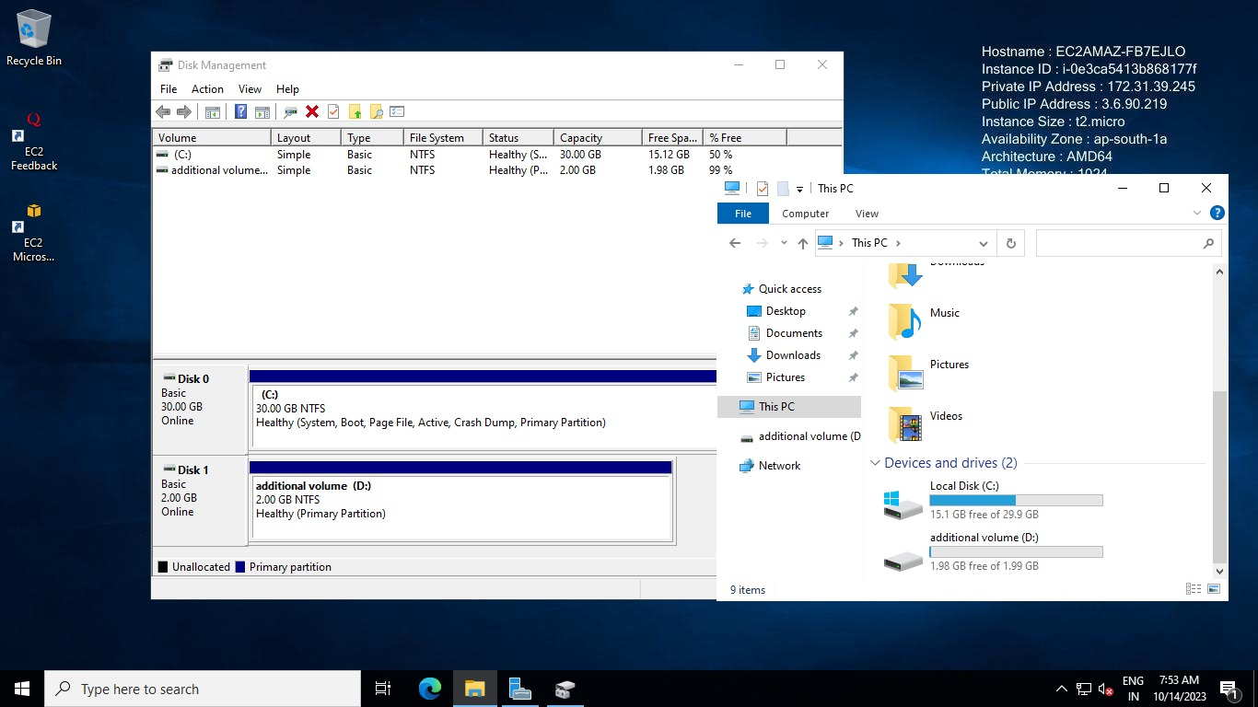

do the same process again and attach all volume

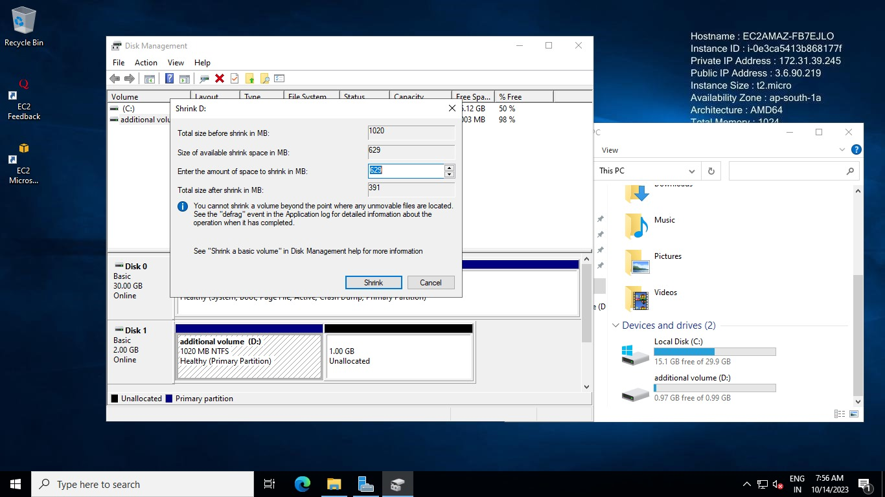

now you can shrink (decrease) the volume too

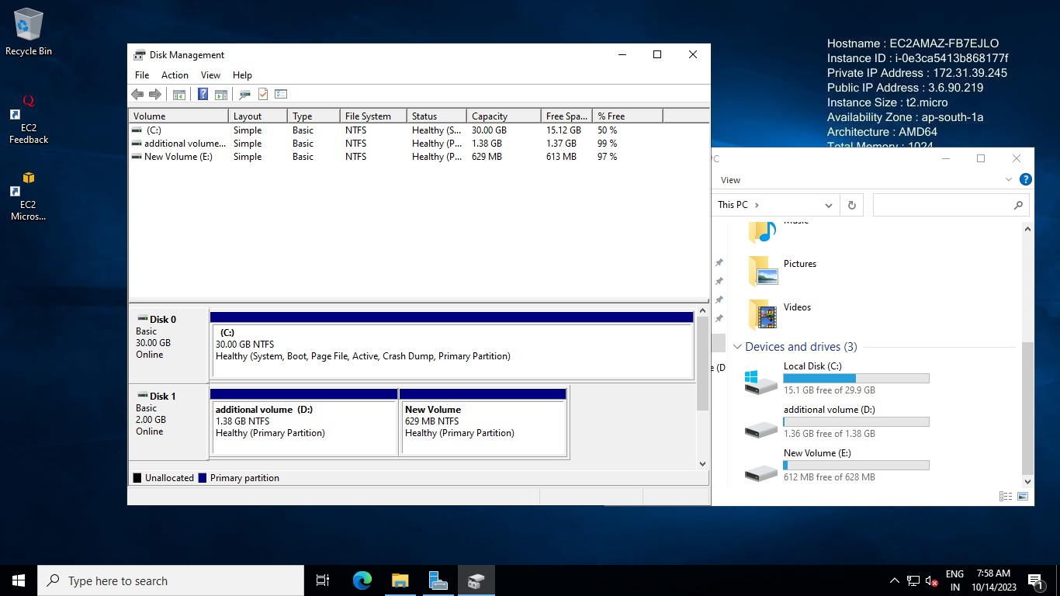

here in windows, we can partition the volume

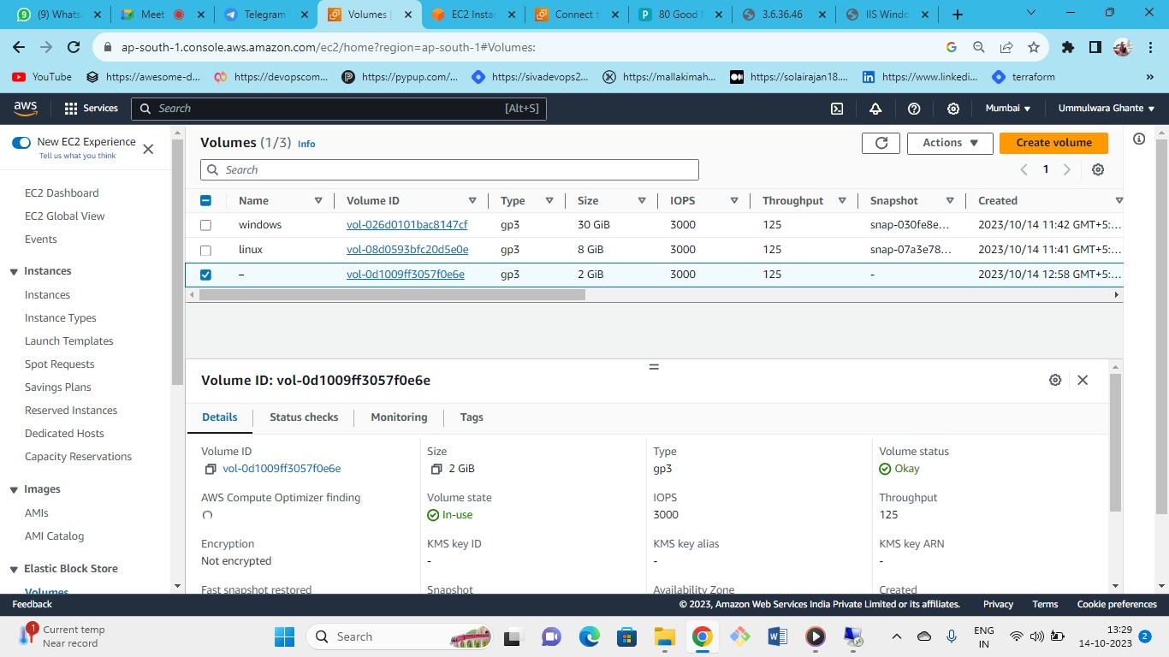



But here its showing 2GB only

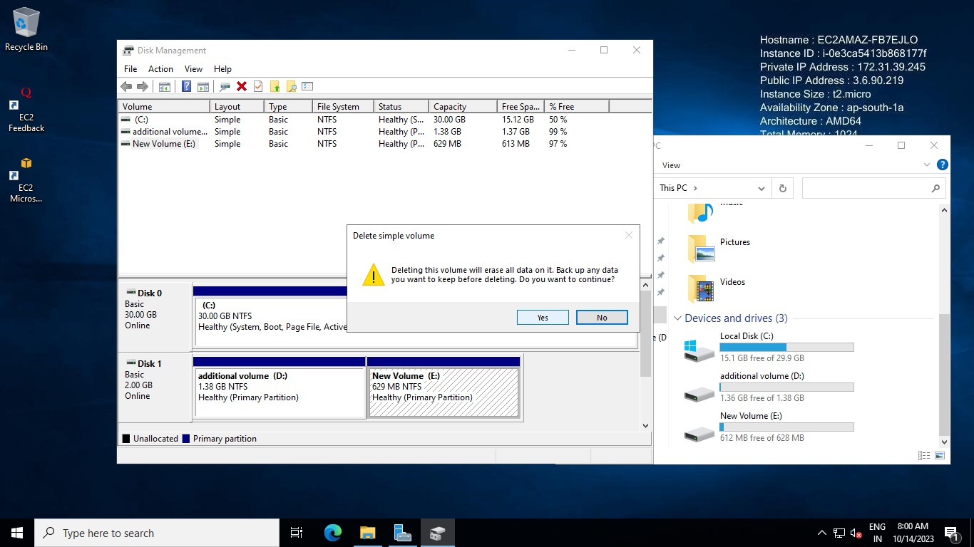

delete the new volume and attach to the additional volume

Note (If we delete the volume E the volume will not get deleted only the name or partition will be deleted so here 629MB will be free and we can attach to our additional volume)

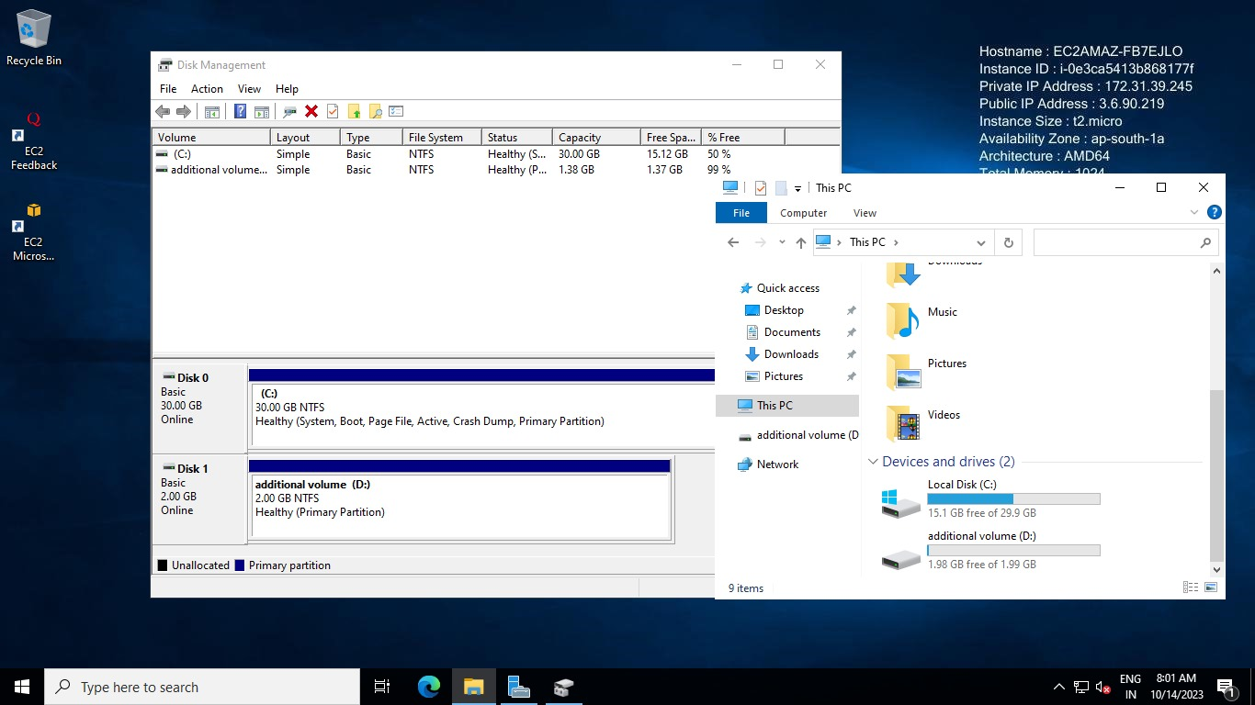

we cannot merge different disk

depending upon the operating system and instance type we can attach the extra volume to one instance.

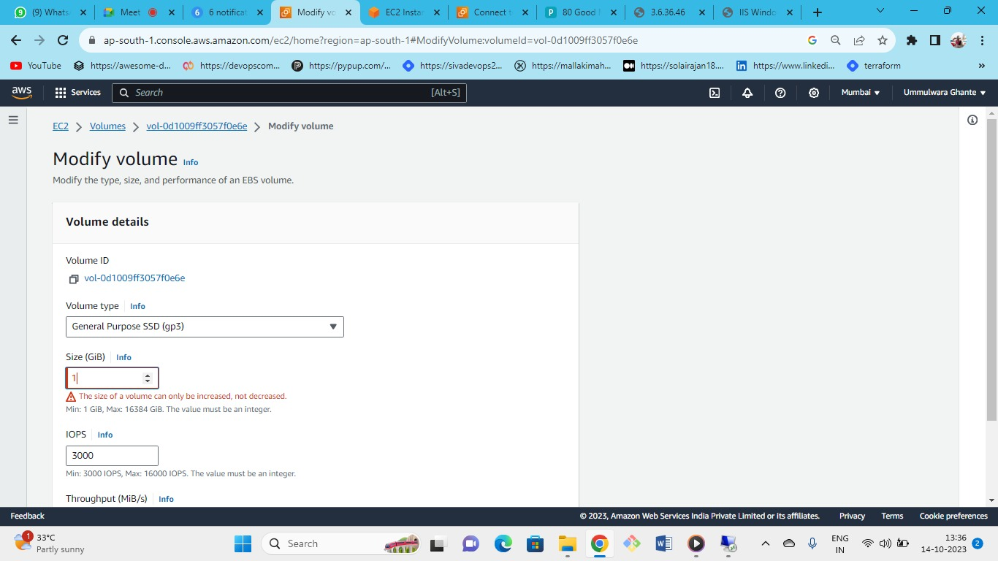



* Note : The size of the volume can only be increased but not decreased
* So need to be very careful before provisioning the volumes because we need to pay the additional charges for the volumes on monthly basis.
* So it is best practice that you should not over provision the EBS volumes.

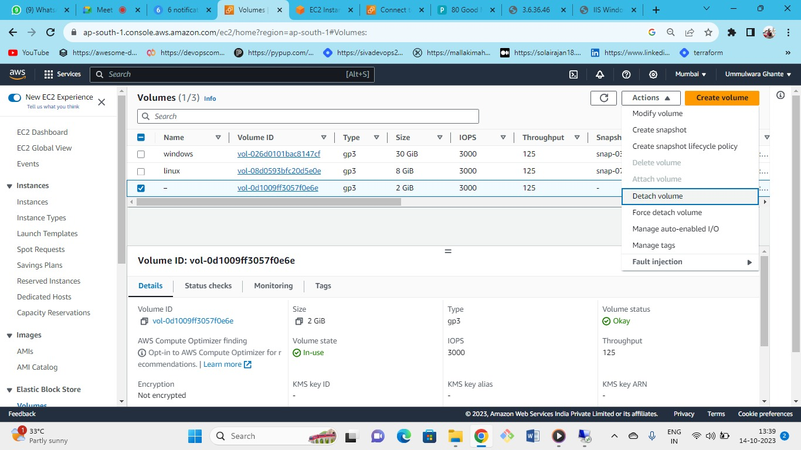



Detach and delete the additional volume that was created for windows instance

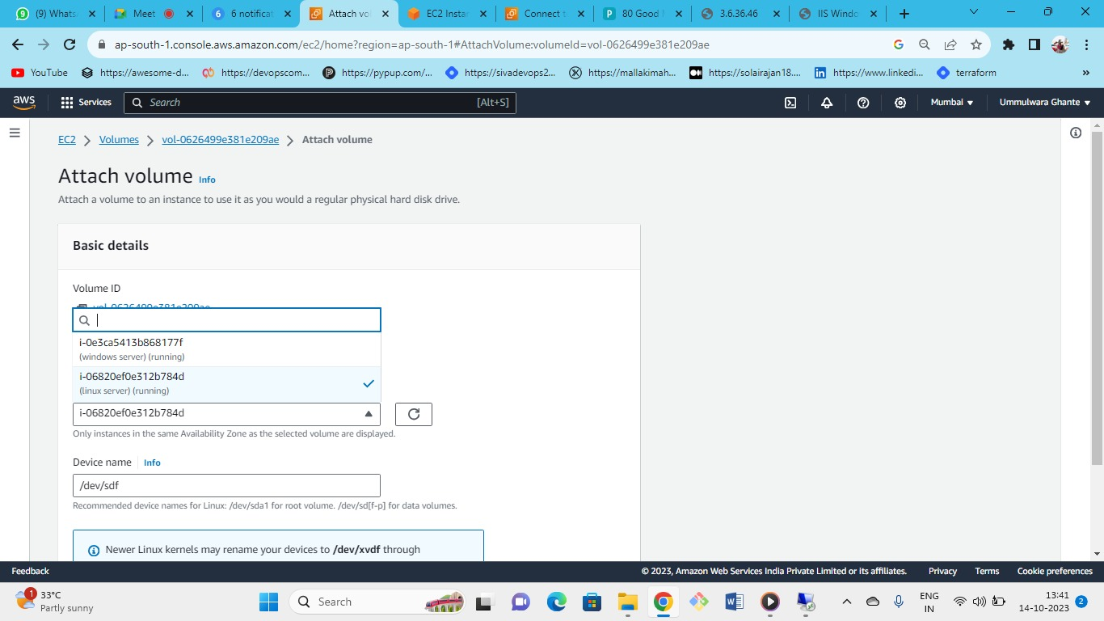



Create one new additional volume and attach it to Linux server

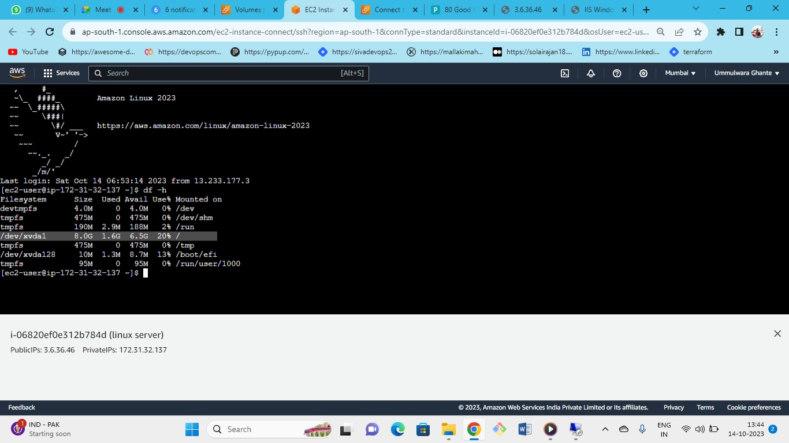



(df -h) disk free 🡪 command to see the amount of volume available

As we have only one volume available (8GB) additional volume we need to attach

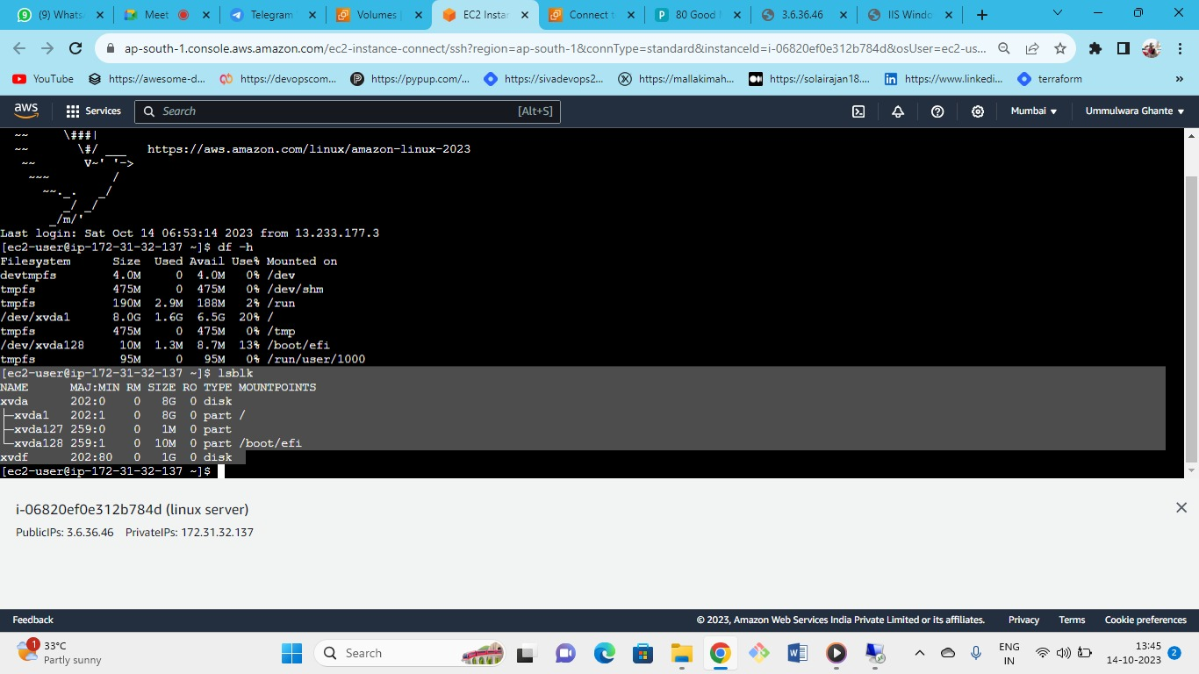



* you can see the list block
* (lsblk) will give us the new volume information, virtual drives and also the partition
* as xvdf (i.e. additional volume) is not mount yet but xvda (i.e. root volume) has the partition and mounted

<https://docs.aws.amazon.com/AWSEC2/latest/UserGuide/ebs-using-volumes.html>

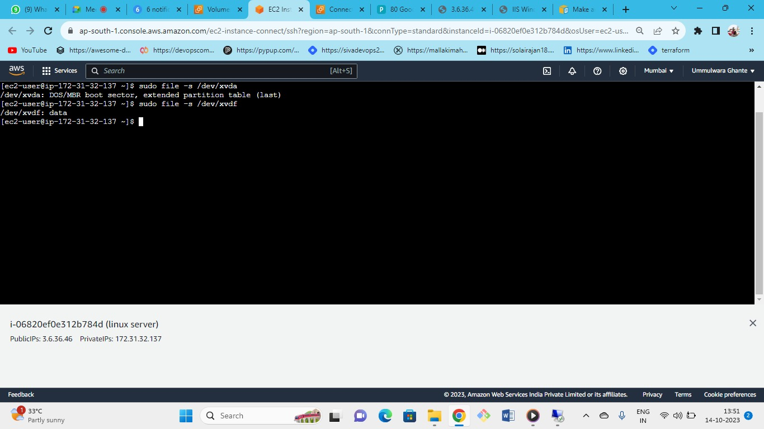



* Sudo file – s command is used to check if file system is written on dev or not
* The file system is important
* As we can see **sudo file -s /dev/xvda🡪** we have got the MBR partition table but for
* **sudo file -s /dev/xvdf🡪** we have only got the data and partition is not done over here
* If only data is written means no file system existing
* So we first need to create the file system

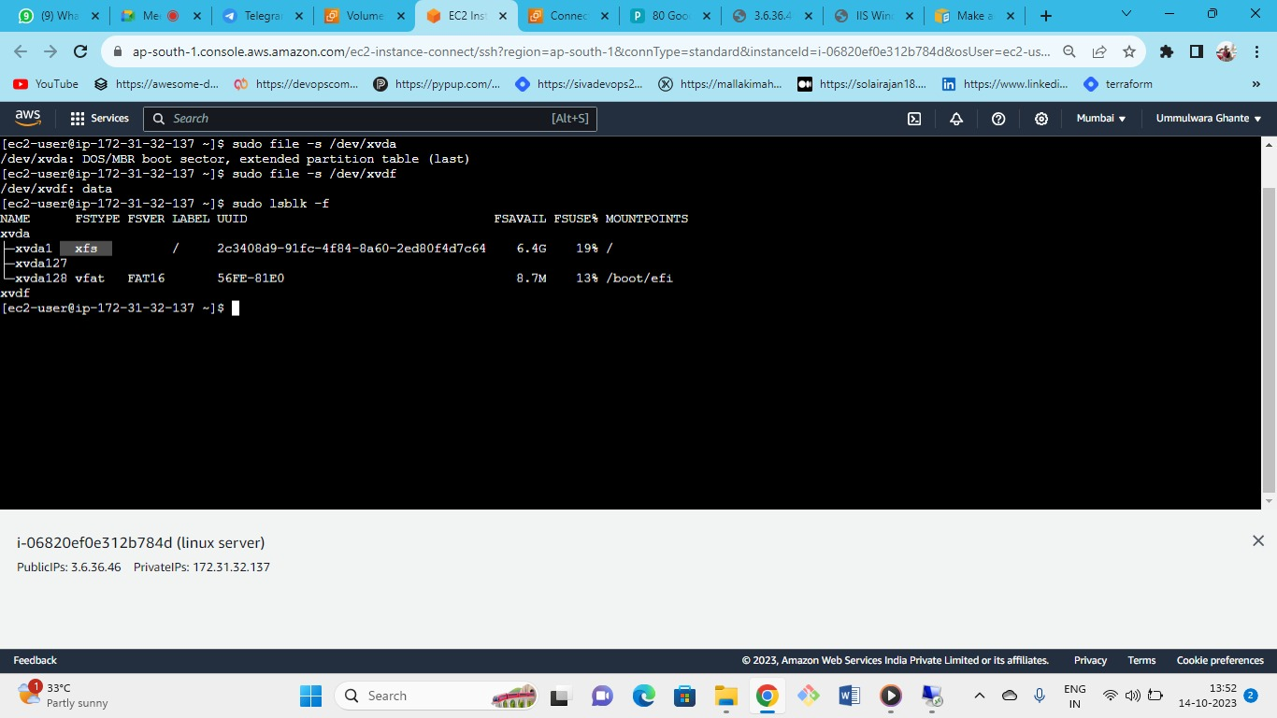



* This command will also give us about the information of the file system type
* it shows the file system type of xvda but xvdf do not have any file system available for the OS
* sudo file -s /dev/xvda1 : command is use for If the device has a file system, the command shows information about the file system type (xfs and vfat).

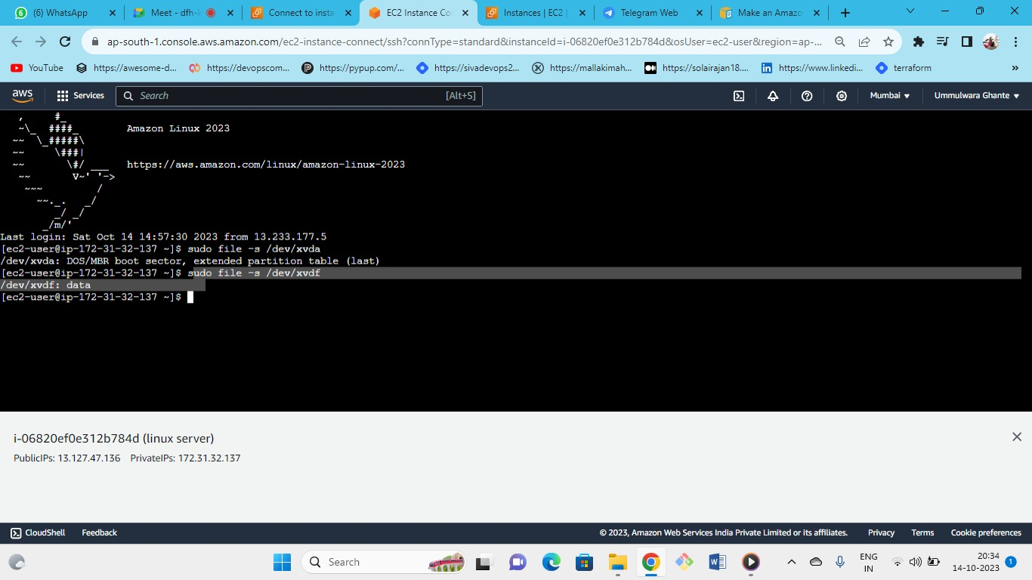



That means no file system is existing first create a filesystem

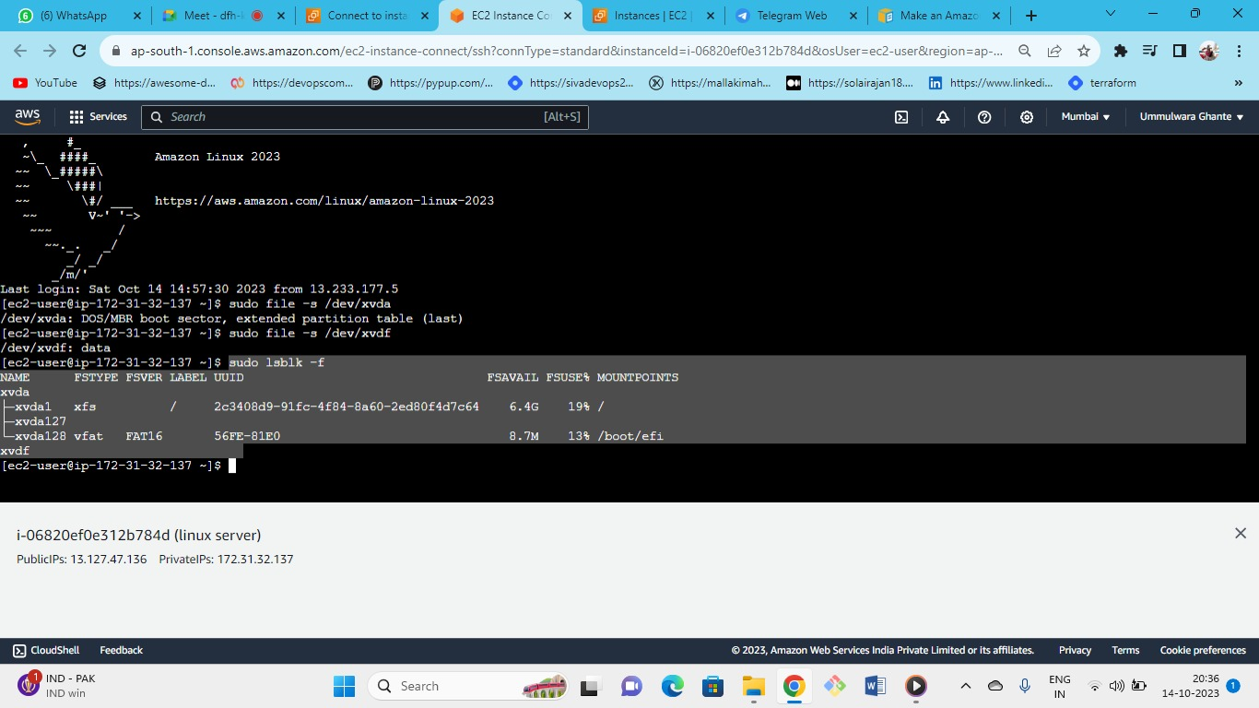



* Use the lsblk -f command to get information about all of the devices attached to the instance.
* and even gives the file system type as xvdf as no file system at OS level
* sudo mkfs -t xfs /dev/xvdf : command if you have an empty volume, use the mkfs -t command to create a file system on the volume.
* mkfs : make file system
* -t: type of file system you need to be make.

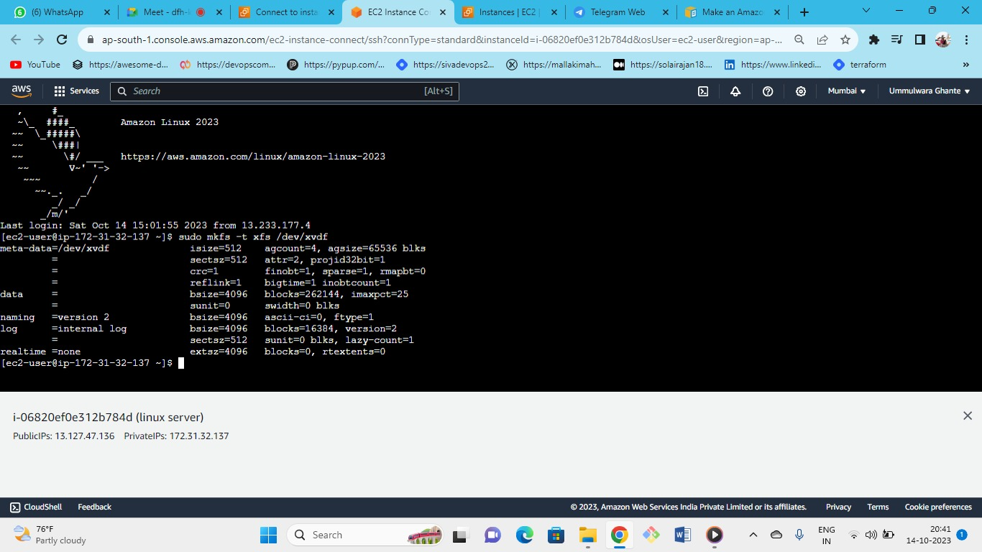



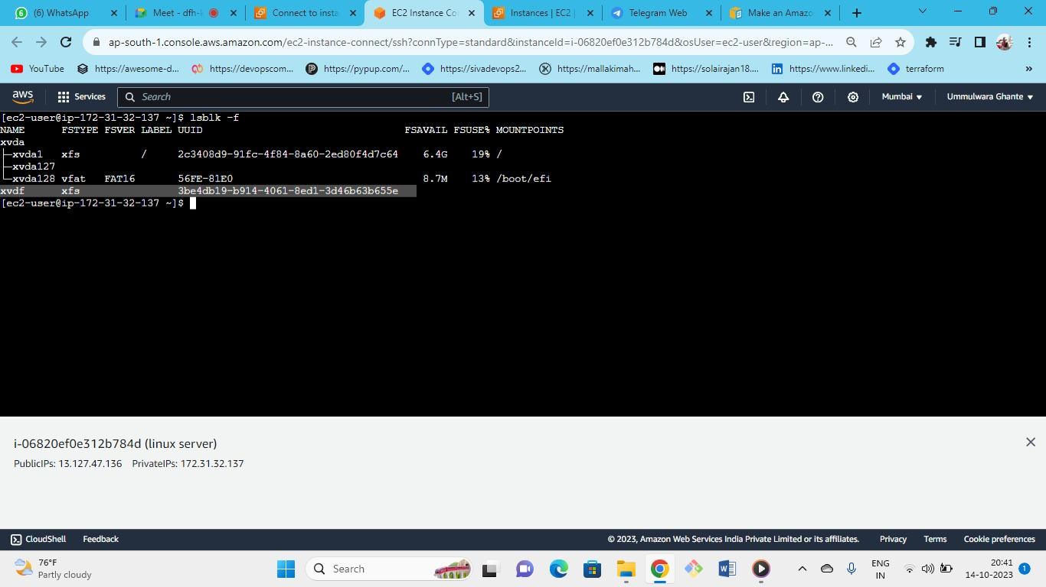



* as you can see a file system has been created for xvdf
* as you can see their is a mount point for xvda not for xvdf (like windows have C,D,E drives which are mountpoints)
* **sudo mkdir /data** 🡪 this command is used to make directory as in linux we work on directories
* Use the mkdir command to create a mount point directory for the volume
* **sudo mount /dev/xvdf /data**
* Mount the volume or partition at the mount point directory you created in the first we have created the directory then mount volume to that directory.
* whenever we are accessing this folder then indirectly we are accessing the volume

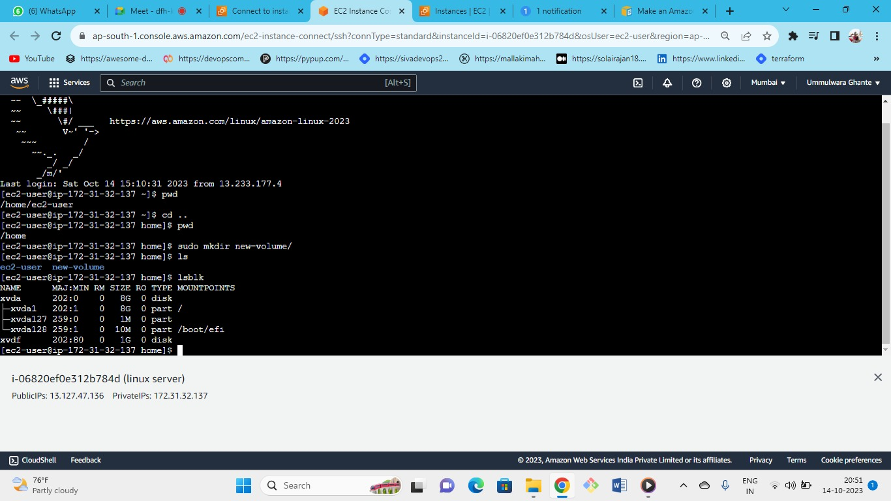



created a new volume as directory

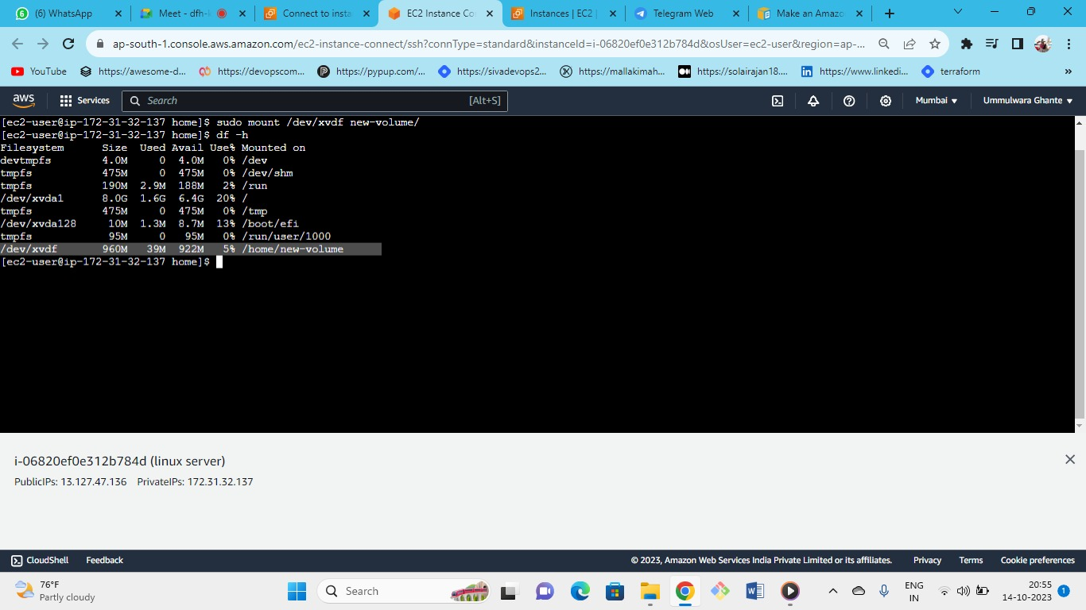



successfully mount on the directory of volume new-volume





As we can see xvdf is mounted successfully on new volume directory

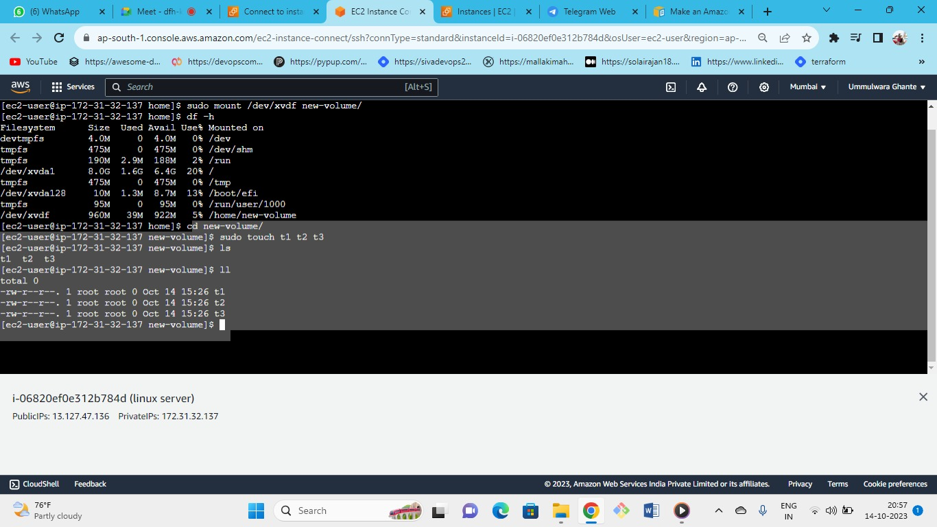



In directory of new-volume we have created file of t1,t2,t3

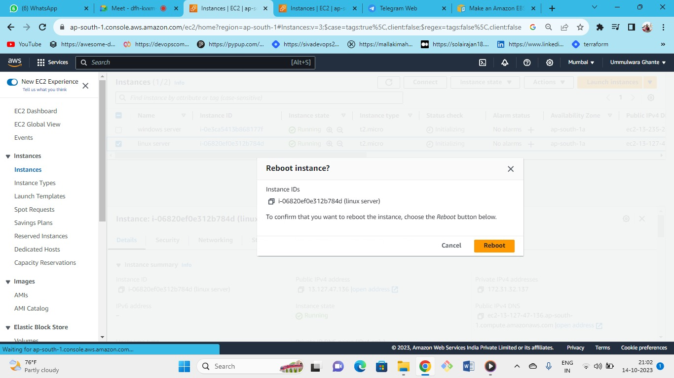



Now reboot the instance

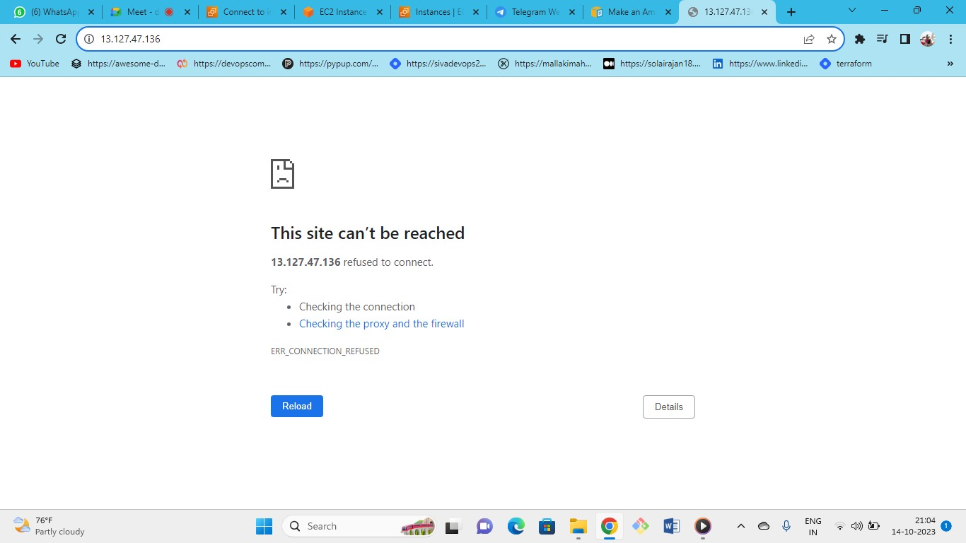



After reboot it’s not working lets check the status of web server

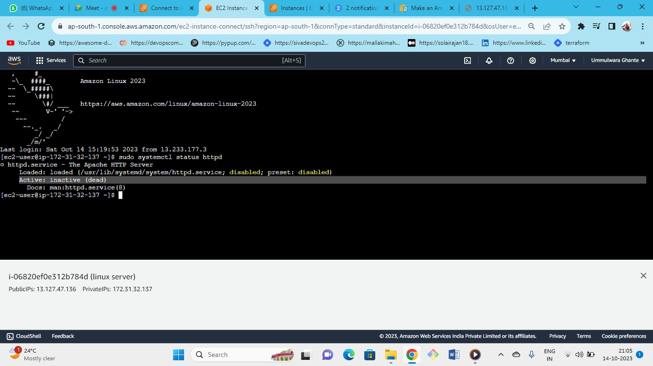



as our webserver is not active that’s why we cant see the webpage

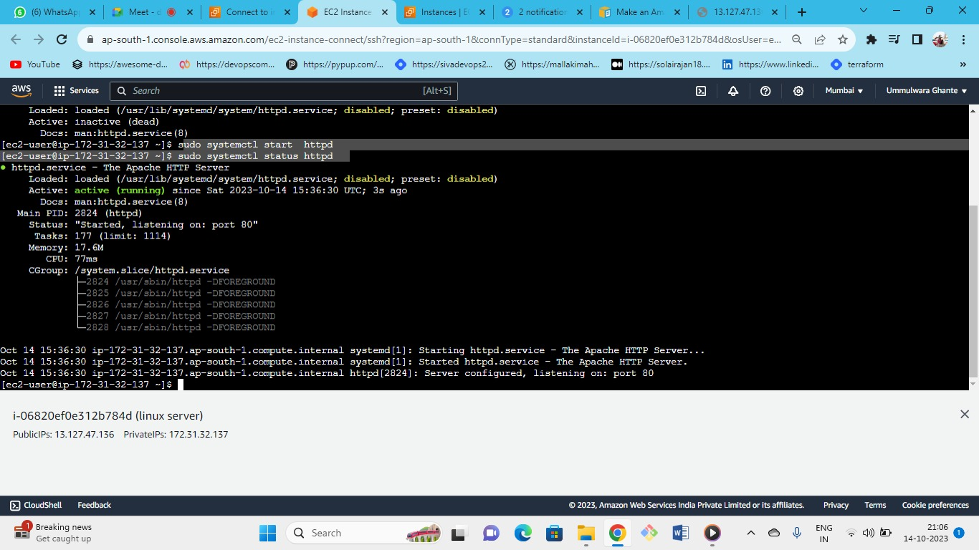



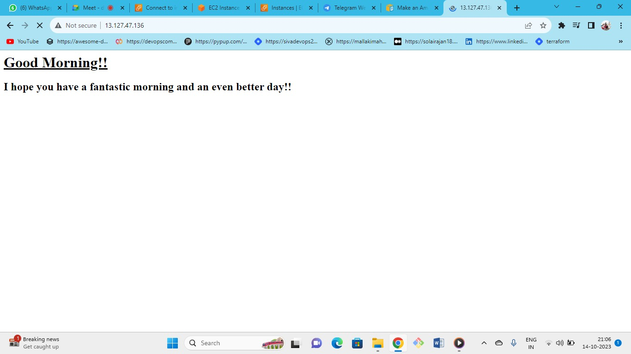



every time you need to do this while rebooting for the production purpose

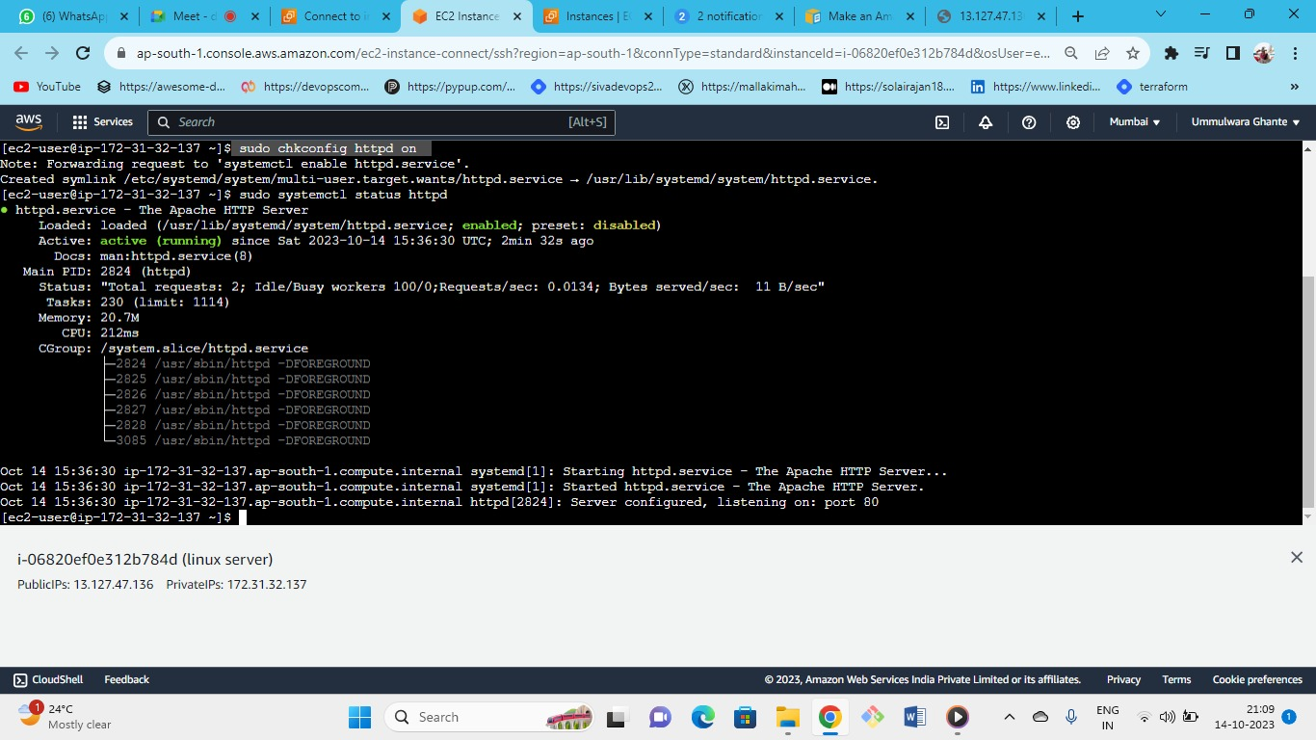



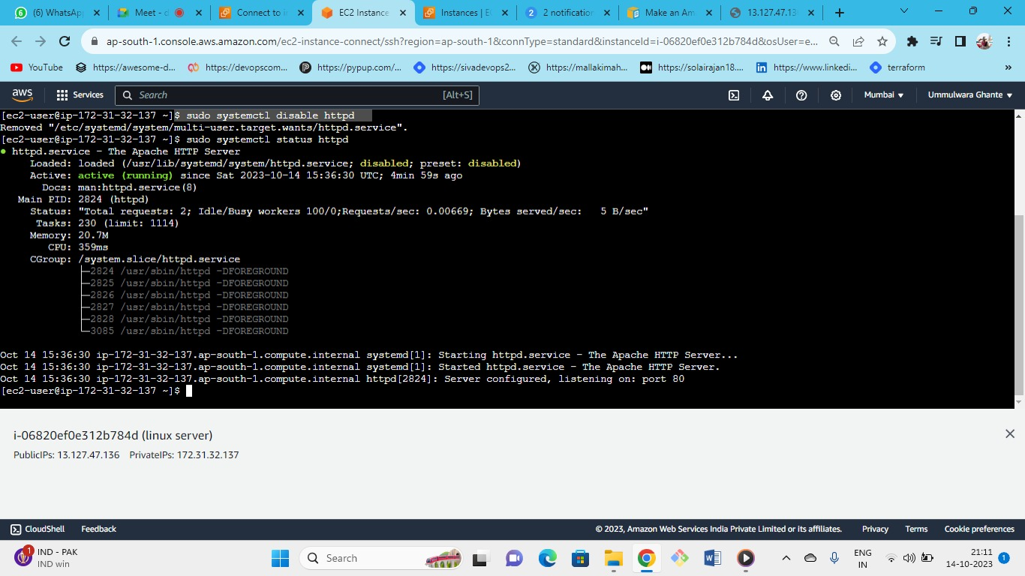



As we can see the service is disabled

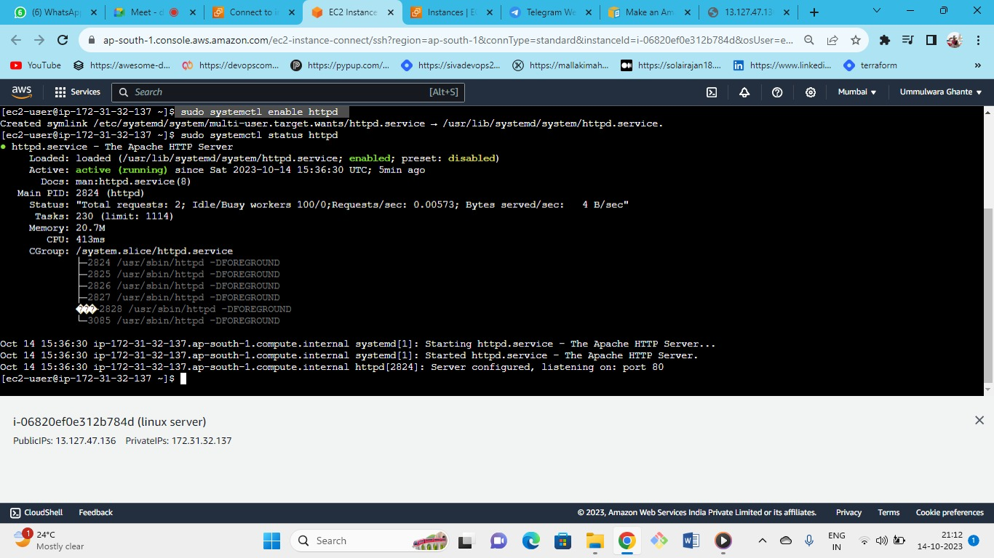



Use the following command to enable

now again if we reboot the system then server will not be stop

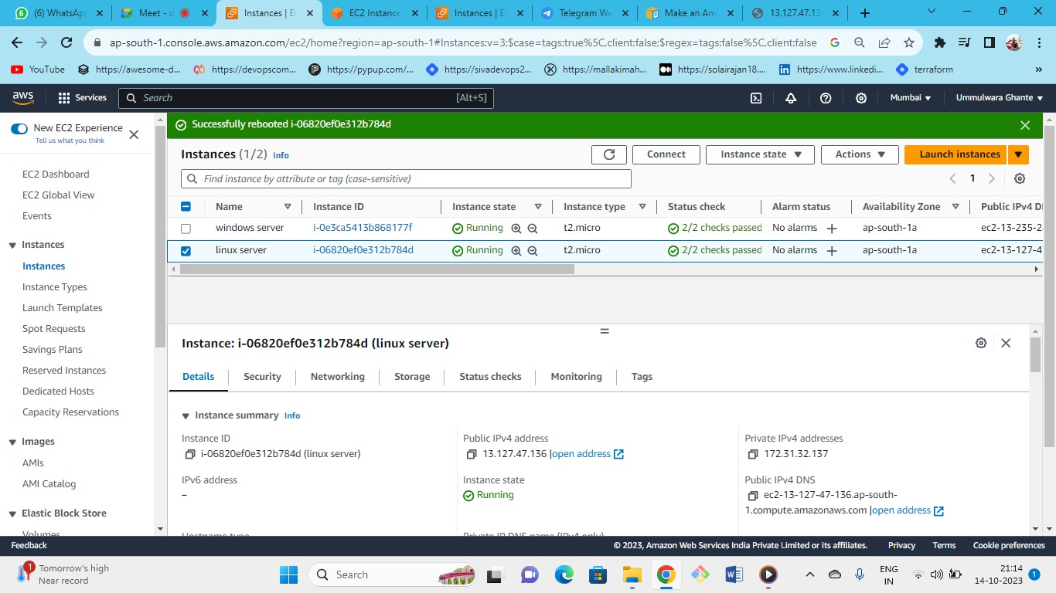



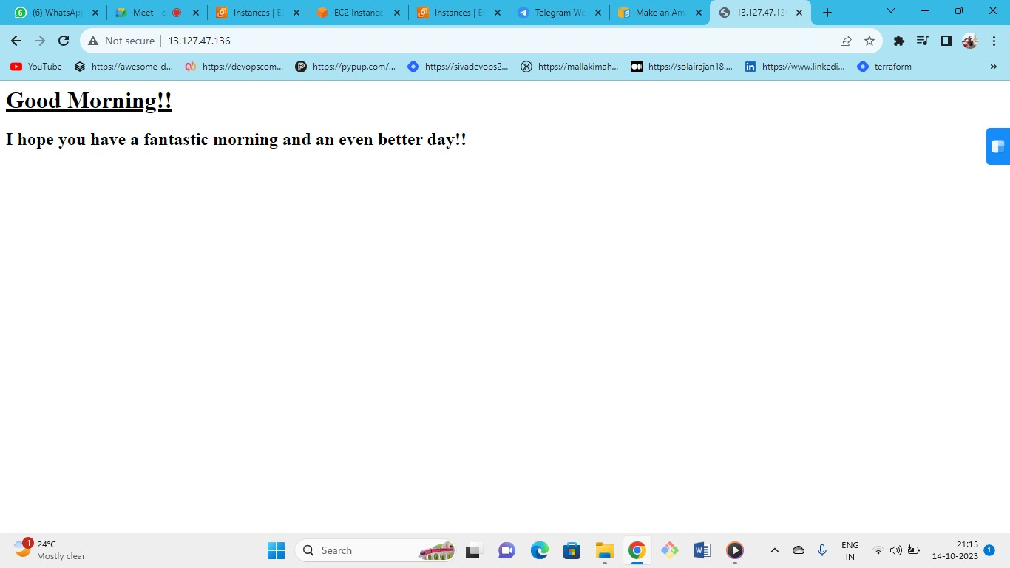



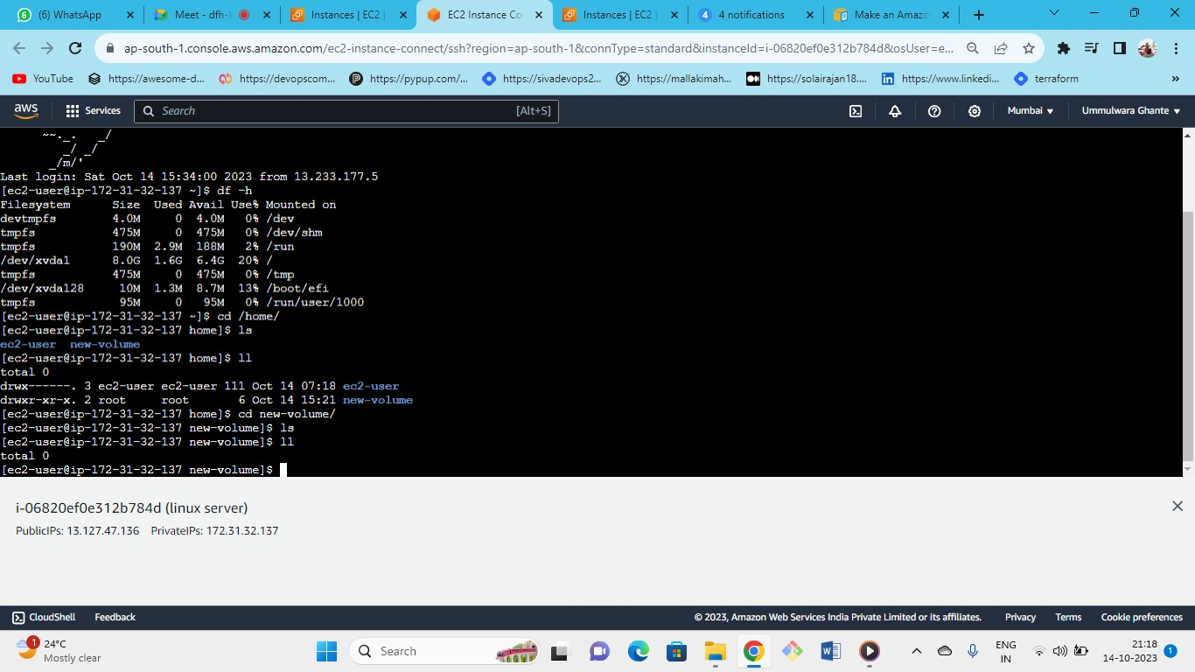



There is no mount point here and even the files (t1,t2,t3) we have created has been gone for the additional 1GB volume

This happened because as you have stop and start the server mount point will be gone but the folder or directory will be there.

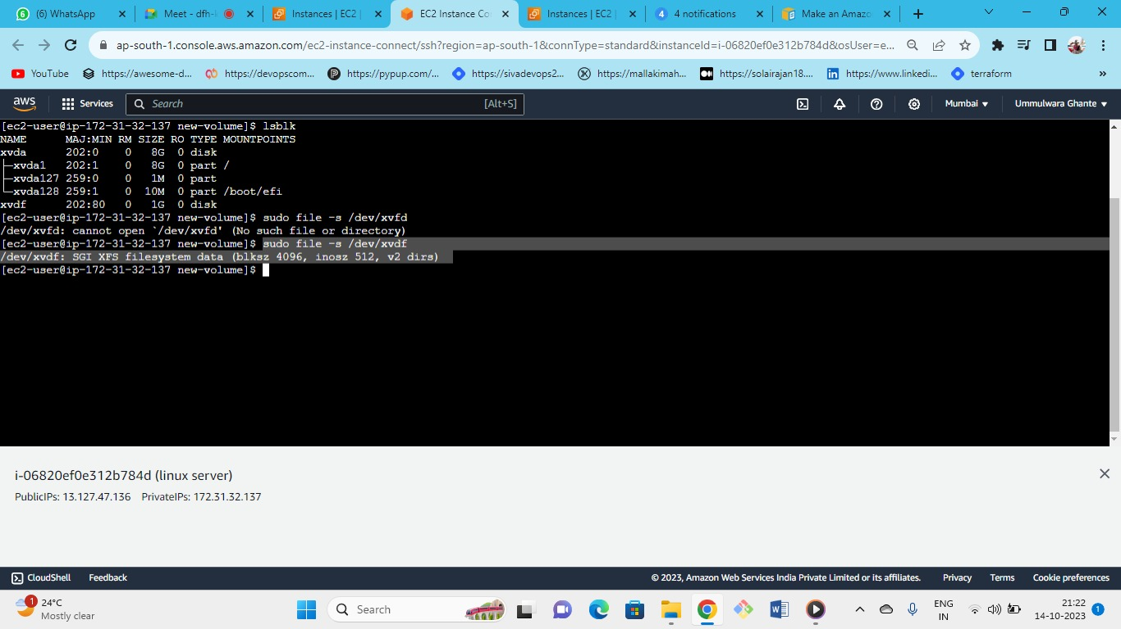



As we can see our XFS file system is available

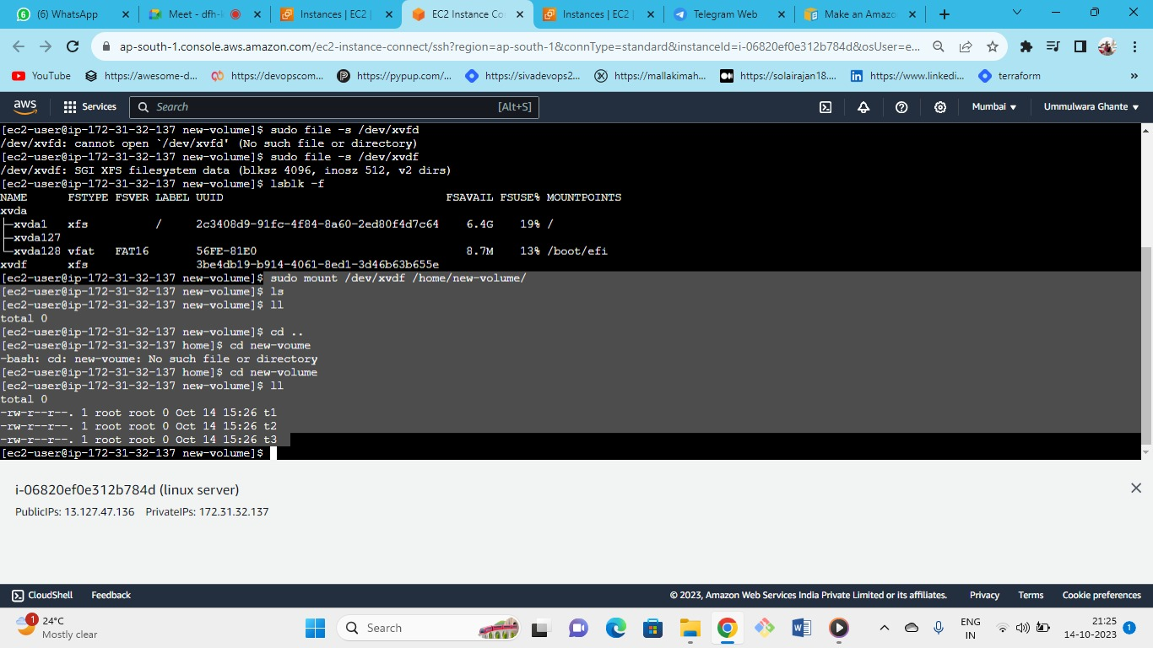



again if you will reboot mount will be gone to do it permanent you need to give the path in the fstab

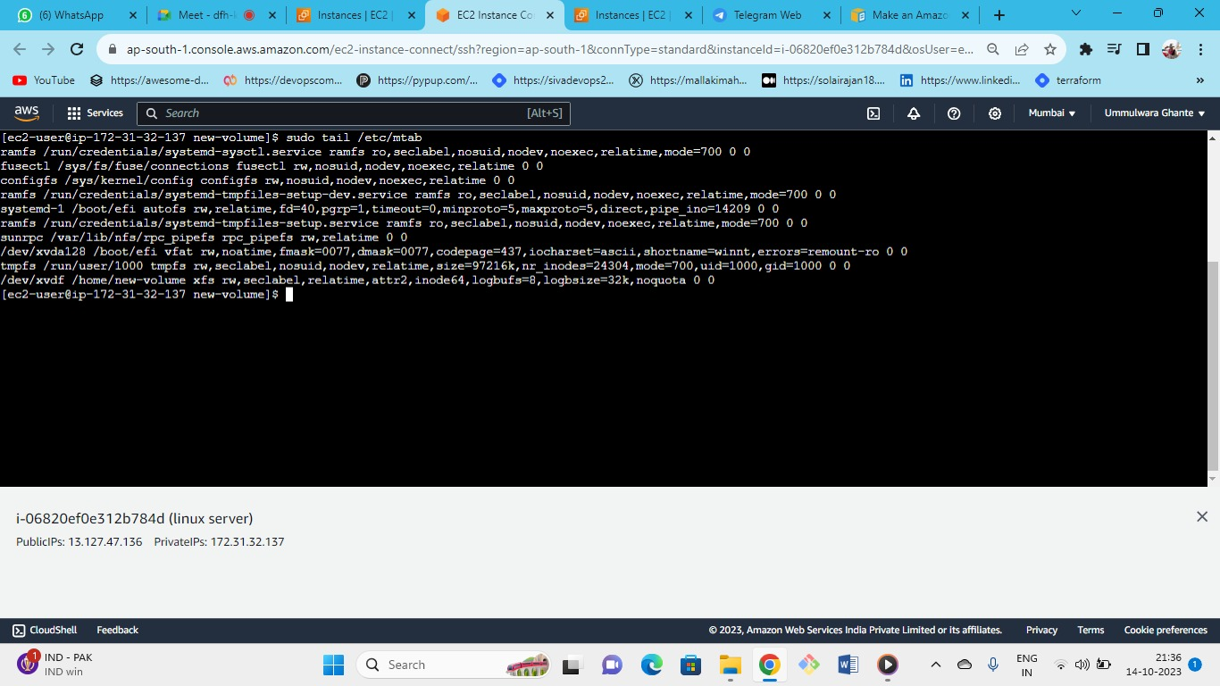



Copy the whole path od /dev/xvdf of the last line

with tail comment you can see the last commands

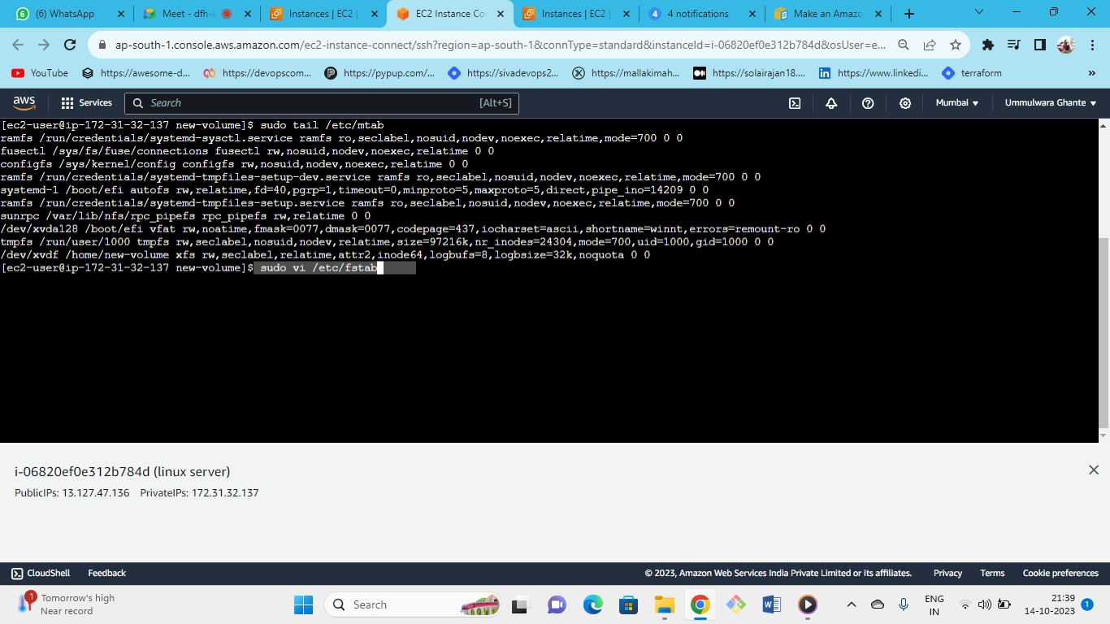



Use the following command to enter the fstab folder

in fstab you need to do entry copy the last command of mtab and paste in the fstab

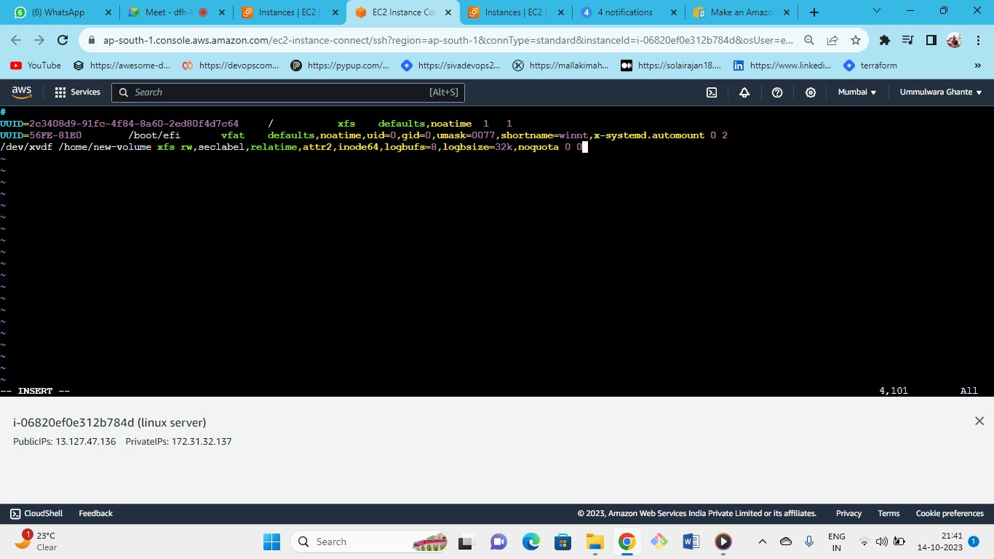



Press i to insert 🡪 paste the path on the 3rd line

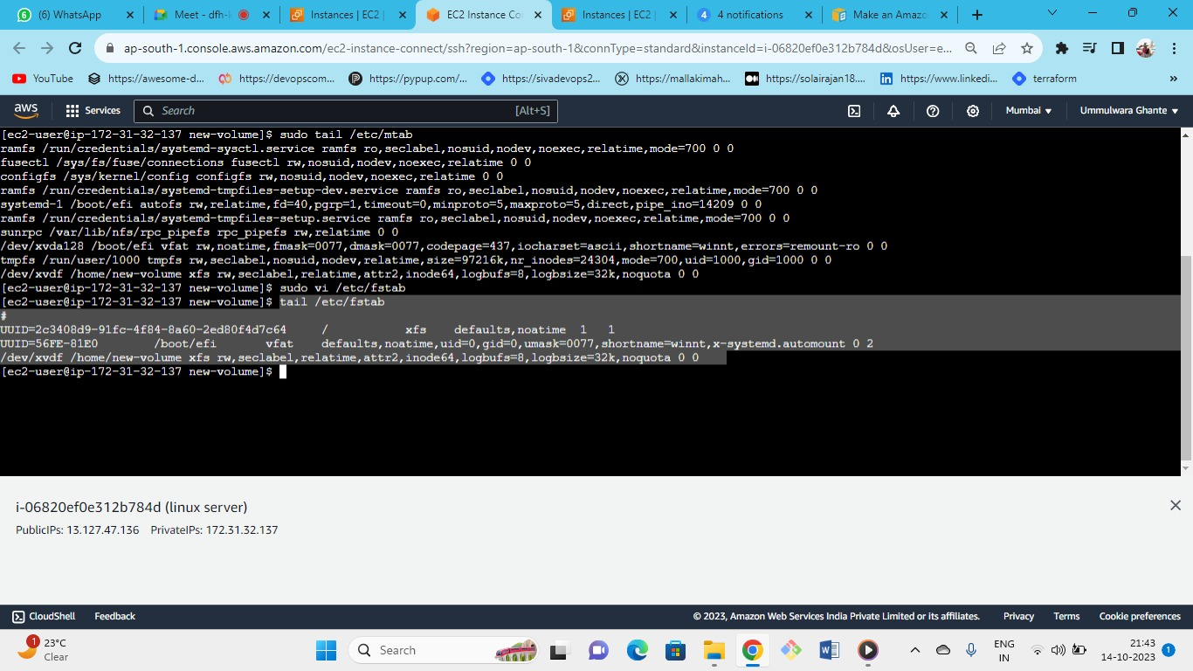



As we can see the entered command in fstab from the tail command

now again reboot the instance

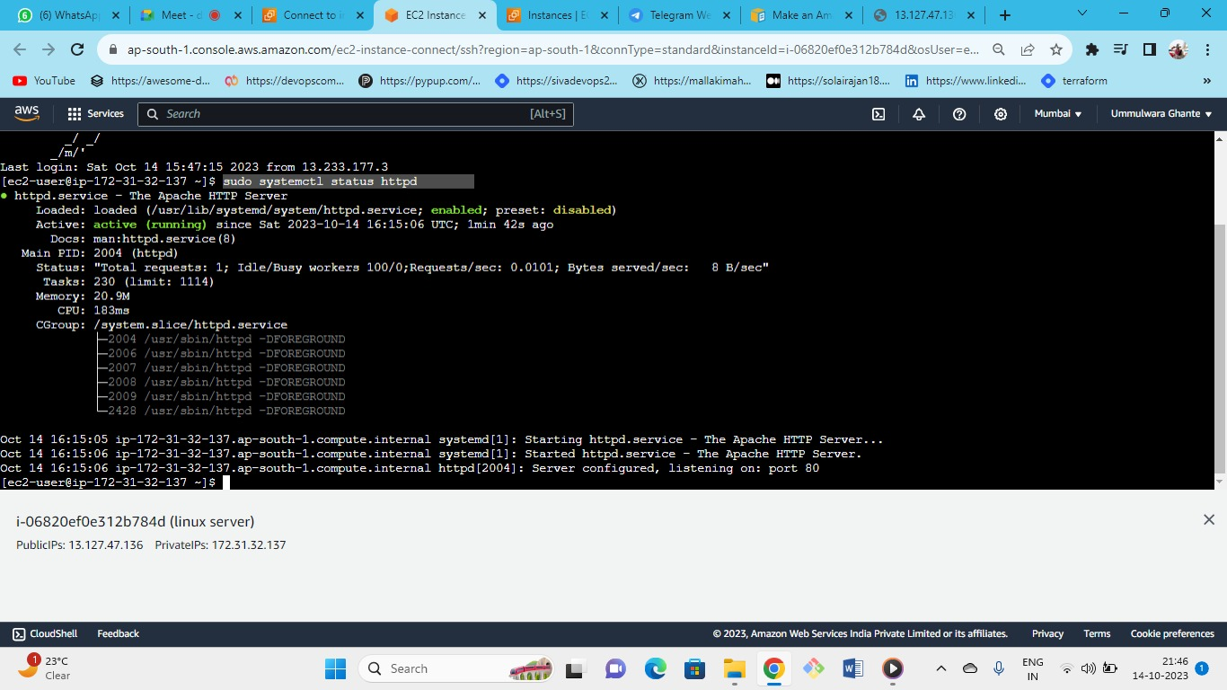



After rebooting as we can see our httpd server is actively running and is enabled

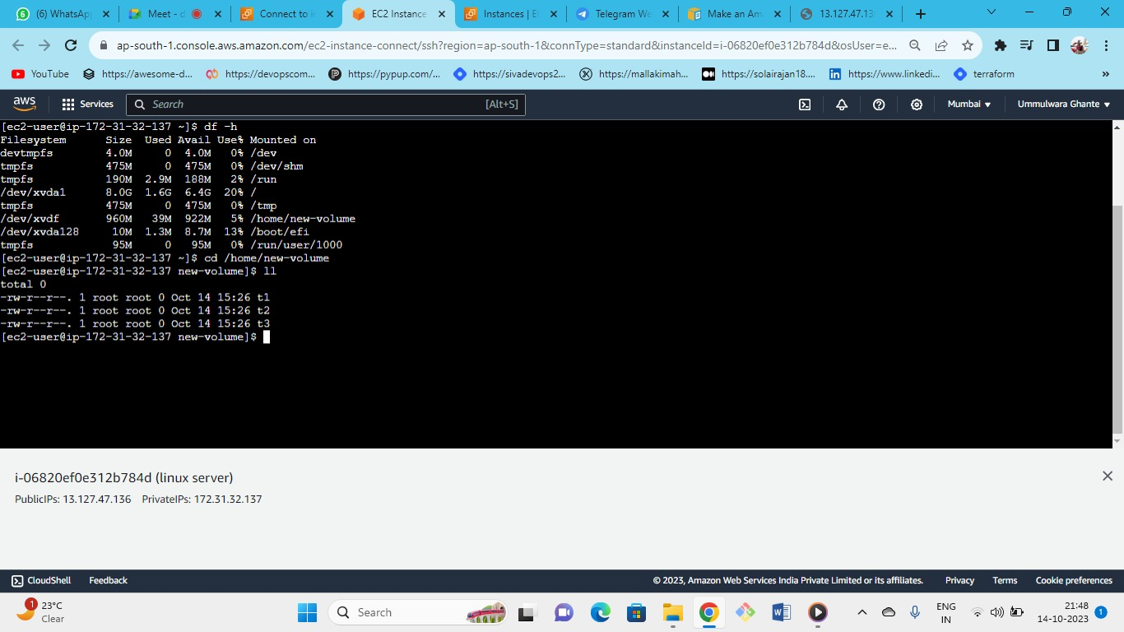



* as we have created a permanent mount by /etc/fstab sand by copying content from /etc/mtab
* all the files are available which were already mounted on the newvolume directory
* now unmount the volume

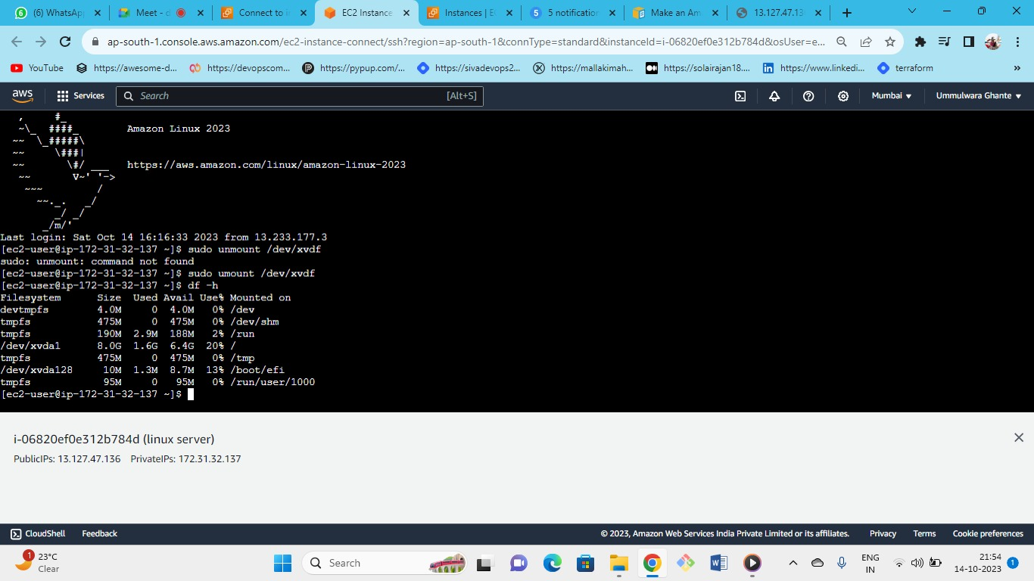



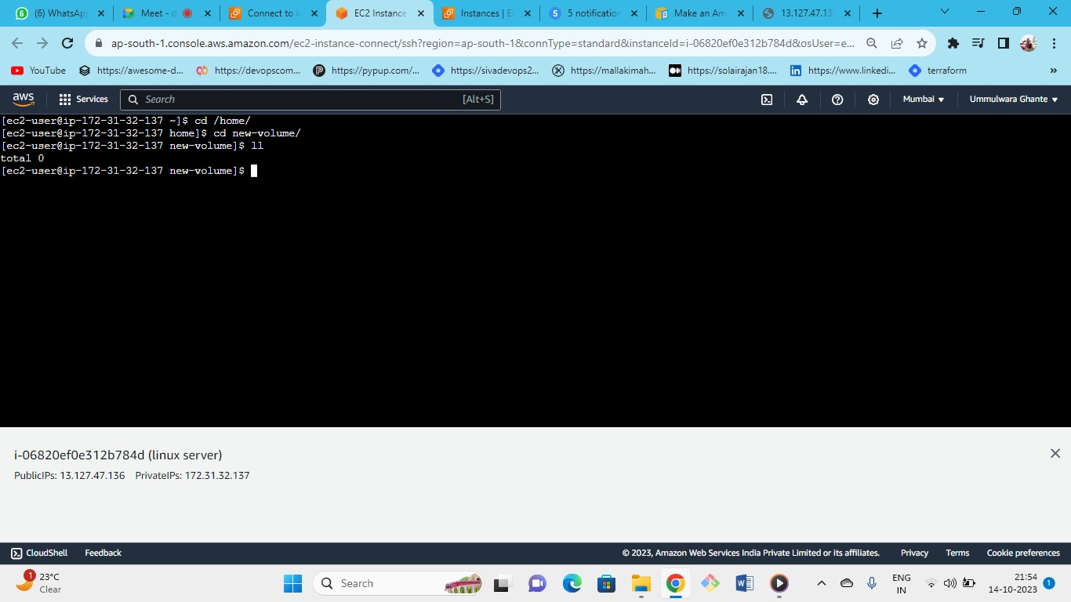



The newvolume has been unmounted successfully.